PROPOSAL FOR RECONNAISSANCE SURVEY (G-4 STAGE) OF GRAPHITE IN SONAGARA BLOCK, BANKURA DISTRICT, WEST BENGAL

Commodity: Graphite

BY
MMPL PRIVATE LIMITED
FR 07 SHILPANGAN, PLOT NO – LB 1,
SECTOR III, SALT LAKE, KOLKATA-700091

Place: Kolkata
Date: 25.06.2026

Summary of the Block G-4 Stage of Exploration

Sl.no | Features | Details
1. | Block ID | Sonagara Block
2. | Current Exploration Agency | MMPL Private Limited
3. | Previous Exploration Agency | MMPL Private Limited
4. | G4 stage Geological Report | N/A
4. | (Previous stage Geological Report) | N/A
5. | Commodity | Graphite
6. | Mineral Belt | North Singhbhum Mobile Belt
7. | Completion Period with entire
7. | Time schedule to complete the project
8. | Objectives | The present exploration program (G-4 stage) has been formulated on the basis of the outcomes of previous work to fulfil the following objectives:  - Geological mapping on 1:12500 scale to delineate Graphite bearing lithological units and other lithological units in the area.  - Delineation of the potential subsurface mineralized zones by Geophysical Surveys (SP survey).  - Trenching will be carried out to expose for collection and analysis of Graphite bearing lithological units to establish the surface thickness of the mineralization.  - Exploratory drilling to prove the depth persistence of graphite mineralization at 30 m vertical depth of intersection.  - Assessment of quality and quantity of the resources (334) if any as per UNFC norms & Minerals (Evidence of Mineral Contents) Rules- 2015.
9. | Whether the work will be carried out by the proposed agency or through out- sourcing and details thereof. | The work will be carried out by proposed agency
9. | Components to be outsourced and name of the out-source agency | The work will be carried out by proposed agency
10. | Name/Number of Geoscientists | Field Geologist: Two numbers  HQ Geologist: Two numbers
11. | Expected Field days (Geology) | 150 Man-days
11. | Geological Party Days | 150 Man-days
12. | Location
  Point | Latitude | Longitude
  A | 22.8990 | 86.9123
  B | 22.8769 | 86.9122
  C | 22.8787 | 86.8105
  D | 22.8564 | 86.7772
  E | 22.7866 | 86.7680
  F | 22.7843 | 86.8437
  G | 22.8362 | 86.8453
  H | 22.8359 | 86.9457
  I | 22.8990 | 86.9465
 | Villages | Sabuj Dweep, Goswamidihi, Dundar, Sonagara, Guniara, Jambani, Bouripal
 | Tehsil/Taluk | Ranibandh, Raipur
 | District | Bankura
 | State | West Bengal
13. | Area (hectares/square kilometres)
 | Block Area | 125.43 Sq.km
 | Forest Area
 | Government Land Area
 | Private Land Area
14. | Accessibility
 | Nearest Rail Head | Bankura Railway station, Jhargram Railway station
 | Road | Khatra Raipur road
 | Airport | Kaji Najrul Airport, Andal
15. | Hydrography
 | Local Surface Drainage Pattern (Channels) | Dendritic pattern
 | Rivers/Streams | Kangshabati River
16. | Climate
 | Mean Annual Rainfall | 1400-1500 mm
 | Temperatures (December)(Minimum) | 9°C
 | Temperatures (June)(Maximum) | 42°C
17. | Topography
 | Toposheet Number | 73J/13
 | Morphology of the Area | The area shows undulatory topography with small hills and river valley sections.
18. | Availability of base line geoscience data
 | Geological Map (1:50000/1:12500K) | Available
 | Geochemical Map | Available
 | Geophysical Map (Aeromagnetic, ground geophysical, Regional as well as local scale GP maps) | Available
19. | Justification for taking up Reconnaissance Survey/ Regional Exploration | Justification for taking up the investigation in G4 stage:  - Mr. Sudipta Lahiri and Mr. Bhupendra Singh (GSI, 1990-93) reported occurrence of Graphite sericite schist during STM.  - To the west of the proposed block, in Ranibandh block, Mr. B.P. Yadav estimated a resource of 0.898 million tonne for zone A at 2.15% to 9.69% weighted average FC and 0.483 million tonne for zone B at 3.08%-8.69% weighted average FC during G4 stage of investigation.  - Fixed carbon values, for 15 numbers of graphite bearing samples collected from the proposed block area of Sabuj Dweep, are ranging from 3.83% FC to 11.89 % FC.

Block Summary

Physiography: The proposed Sonagara Block shows a undulatory topography with hills, river valleys and nala sections.

Climate: The proposed block area experiences a tropical monsoon climate. Summers are hot and dry with high temperatures 40–45 °C in peak months (April–May), the monsoon season (June–September) brings most of the annual rainfall of about 1150–1500 mm, and winters are mild and dry (10–15 °C). Overall, the climate is characterized by hot summers, moderate to heavy monsoon rainfall, and pleasant winters, typical of the interior Rarh region of West Bengal.

Drainage: few intermittent (or Seasonal) Nalas are flowing towards southerly following Darakeswar River which is flowing in the western side of the block area. The overall drainage patter of the area is dendritic in nature.

Background Geology (Regional Geology, Geology of the Block):

Regional Geology
The seminal works of J.A. Dunn and A.K. Dey, which appeared in 1929, 1941 and 1942, provided the basis of the reconstruction of geological design and history of southern Jharkhand and adjoining Odisha. The Palaeoproterozoic in eastern India is represented by the Singhbhum Mobile Belt. It abuts against the Chhotanagpur gneiss in the north and its southern boundary is demarcated by a deep-seated fracture, described as the copper belt thrust by Dunn and Dey or Singhbhum shear zone (Sarkar and Saha 1962; Sengupta and Ghosh 1997). The southern boundary provided passage to basic and alkaline magmas and mineralizing solutions (Banerji 1962; Banerji et al. 1972). Following the tectonic upheaval—to which the emplacement of the Singhbhum granite is related—a depression is formed between the Singhbhum granite and Chhotanagpur gneiss. The development of the depression is probably related to the formation of the Singhbhum shear zone as a gravity fault. This fault was active time and again all through the history of the mobile belt. The depression became the site of prolonged sedimentation and large-scale volcanism represented by the Chaibasa–Dhalbhum–Dalma–Dhanjori–Kolhan succession. The Singhbhum orogeny converted this pile into a synclinorium, with attendant metamorphism and emplacement of Chakradharpur, Arkasani and Mayubhanj granites, leading to the evolution of the Singhbhum Mobile Belt. The Singhbhum Mobile Belt lies in the oval-shaped zone of high bouguer anomaly, implying the presence of high-density material beneath the metamorphosed flyschoid assemblages associated with voluminous volcanic rocks (Verma et al. 1984; Verma 1985).
Structural Architecture
The succession of metamorphosed flyshoid sediments and lavas of the Singhbhum domain was deformed into E to W oriented folds that are overturned southwards, and are characterized by sub horizontal axis. The E–W trending folds are superimposed by later folds. The axial planes of the folds trend NNE–SSW to NE–SW in the south-eastern part of the Singhbhum domain and E–W in the western sector (Sarkar and Saha 1962). It will be noticed that in respect of the pattern of deformation and orientation of structures, the Singhbhum Mobile Belt bears considerable similarity with the Satpura and Aravali Mobile Belts. The more than 200 km long and 1 to 5 km wide Singhbhum shear zone is characterized by multiplicity of thrust planes with variable upward displacement of northern block and then their flaying out into a number of diverging faults in the south. The shear planes show down dip mineral lineation inclined 45°–70° NNE. There are several bands of mylonites formed during the first phase of deformation (Sengupta 1972; Mukhopadhyay 1976, 1984; Bhattacharyya and Sanyal 1988). The mylonites of the Jamshedpur–Mosabani sector exhibit three generations of reclined folds associated with heterogeneous deformation due to N–S and NNE– SSW sub horizontal compression and subsequent strong shear movements related to thrusting (Ghosh and Sengupta 1990). In the median part of the mobile belt, a thrust has uprooted the pile of the Dalma lavas and abruptly cut the conspicuous “V” and “U” shaped closures of later generation cross-folds. There are a number of wrench faults, some dextral and others sinistral, dislocating even the Singhbhum shear zone. In the northern part of the Singhbhum domain, the 200 km long intra-formational thrust, known as the Northern Shear Zone, has brought high-grade metamorphic rocks of the northern belt upon low-grade metamorphic rocks of the shear zone. The shear zone is characterized by schistose mylonite, reclined folds with axial-plane schistosity showing down dip lineation and rotation of folds in the direction of stretching lineation (Saha 1994; Bhattacharya 2004b).
Stratigraphy and Sedimentation
On the basement of the Archaean iron ore Group and Singhbhum granite rests a succession of mildly to moderately metamorphosed sediments. The succession is divisible into three groups (Figure 1)—the Chaibasa–Dhalbhum group of flyshoid assemblage (Gaal 1964; Bose 1994), the Dalma volcanics, and the Kolhan Group of molasse assemblage (Table 1).
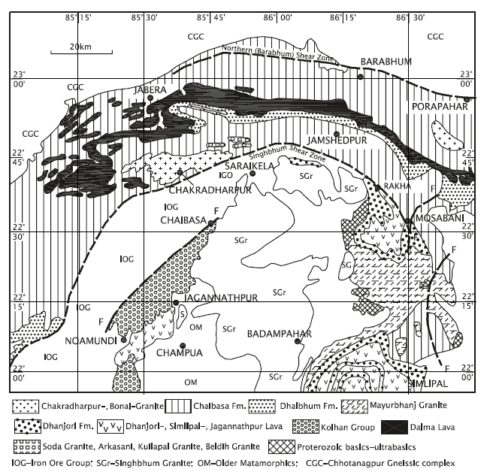
The Kolhan is separated from 159 the Dalma by an unconformity, and the Dalma volcanics are associated with the Dhanjori sediments. The Chaibasa sediments were deposited in the intertidal zone as small overlapping submarine fans along the eastern margin of the craton by rivers that flowed in the NE/NNE direction (Naha 1962). The succession comprises thick sandstones and shales with numerous horizons of turbidites exhibiting slumped structures, sand filled shallow channels and olistostromes (Das 1997). The sediments were frequently shaken by earthquakes that generated mass movements under water (Bose et al. 1997).
Figure 1: Geological map of Singhbhum mobile belt (after Saha, 1994)
West of the Singhbhum domain in the district of Sundargarh and Sambhalpur M.S. Krishnan in 1937 recognized a succession of rocks very similar to the Chaibasa–Dhalbhum lithology. Resting on the foundation of the Iron Ore Group, the Gangpur group forms a syncline. The southern flank of the syncline is overturned northwards, and the northern flank steeply dips southwards (Kanungo and Mahalik 1972). The eastern closure of the Gangapur synclinorium is characterized by eastward-plunging isoclinal folds and coaxially folded upright folds. Succeeding the Archaean iron ore group without apparent discordance, the Raghunathpalli conglomerate at the base of the group gives way upwards to a succession of carbonaceous quartz–phyllite and banded quartzite (Chaudhuri et al. 1998). Sand and mud accumulated on the subsiding floor of the Singhbhum basin. Simultaneously, volcanoes poured out lavas and ejected volcaniclastics on a grand scale, giving rise to a 150-km-long median belt of volcanic rocks—Dalma volcanics—as seen in the Dhanjori, Dalma, Jagannathpur and Simlipal areas. The name Dalma was given by V. Ball in 1881. Unconformably overlying the Dalma volcanics as well as the Singhbhum granite, the Kolhan group is a multistoried package of terrigenous sediments (Saha 1948). It comprises purple sandstone and conglomerate at the base, followed upwards successively by thick argillites, stromatolitic limestone and phyllite. There are three parallel sills within the succession. The monotonous grey, current bedded quartzites are intercalated with shales. The palaeocurrent pattern indicates derivation of detritus from east and southwest. Together with the fining-upward sequence, the vertical and lateral facies variation in the Kolhan implies superimposition of retrograding shorelines on an earlier prograding alluvial fan of a sand complex laid down in an embayment (Ghosh and Chatterjee 1990).

Table 1: Lithostratigraphy of the Singhbhum Mobile Belt (Saha 1994)
Newer Dolerites (1600–950 Ma)
Mayurbhanj Granite (2110 Ma)
Mafic–Ultramafic intrusive
Kolhan Group: (2100–2200 Ma) | Purple sandstones, conglomerates argillites, stromatolitic limestone and phyllites
…………………………………. Unconformity …………………………………
Dalma Volcanics (2300 Ma) | Lavas, agglomerates and tuffs
Dhanjori Formation | Sandstones, shales and conglomerate and predominant lavas
Dhalbhum Formation | Phyllites, quartzites and epidiorite sills
Chaibasa Fm. (2300–2400 Ma) | Sandstones–shales with numerous horizons of olistostromes and turbidites
………………………………… Unconformity …………………………………
Singhbhum Granite/Iron Ore Group

Volcanic Activities
The Dalma volcanics form a 200-km-long and 3–7-km-wide E–W trending arcuate belt practically in the middle of the Singhbhum Mobile Belt. Exhibiting green schist facies metamorphism, the mafic and ultramafic volcanics of both eruptive and explosive phases are folded into a syncline (Naha and Ghosh 1960; Yellur 1977; Gupta et al. 1980; Bhattacharyya and Dasgupta 1979; Bose and Chakraborti 1994). The volcanic succession is divisible into two units. The lower unit, made up of highly magnesian ultrabasics with actinolite schists, belongs to the picrite suite characterized by low concentration of Na, K, Zr, Y, Ti, P and Sr but higher amounts of Ni and Co and strong LREE depletion. The upper unit comprises pyroclastics and mafic lavas. Lenses of tuffaceous material characterize the sequence of lavas that are vesicular and occasionally pillow-shaped. They belong to the tholeiite suite, mostly depleted in LREE. There is a broad consanguinity of the ultrabasic and basaltic lavas derived from similar sources. The Dalma volcanic activity is related to rifting of the protocontinental crust that allowed tapping of mantle and extrusion of melt (Sarkar 1982, 1988; Saha et al. 1988; Saha 1994). There is another view that the Dalma volcanics belong to N-type mid-oceanic ridge basalt. Exhibiting geochemical signature of depletion, the Dalma volcanics appear to have evolved in the back-arc setting (Bose and Chakraborti 1994). The gabbro and pyroxenite intrusives of the volcanic assemblage showing depletion of LREE, flat HREE and enrichment in LILE similar to the komatiitic and tholeiitic Dalma lavas originated from a mantle plume that eventually rifted the continental crust and allowed emplacement of magma around 1619 ± 38 Ma (Roy et al. 2003). The Dalma volcanics are described by different names in different sectors within the Singhbhum mobile belt. The Dhanjori lavas, forming an asymmetrical syncline overturned westward is associated with sandstones shales and conglomerate. The lavas are petrochemically similar to the contemporaneous Dalma lavas (Saha 1994). It was earlier described as a spilitic suite (Iyengar and Alwar 1965). Ranging in composition from basalt to andesite and showing affinity with the island-arc tholeiites, the iron-enriched volcanics of the Dhanjori formation were emplaced on the margin of the continent margin (Alvi 1992; Alvi and Raza 1991). The associated conglomerate, coarse sandstone and shale represent a fluvial fan complex intercalated with volcanoclastic material within the fining-upward fluvial cycle (Mazumder 2005).
The Simlipal hill is made up of conglomerate and arkosic sandstone overlain by spilitic/mafic volcanic comprising predominant tuffs and lavas and capped at Amjori by a 800-m-thick sill (Iyengar and Banerji 1964). The Amjori sill is a differentiated body of dunite at the base, grading through picrite and dolerite to quartz–dolerite at the top. Sills and dykes of quartz–dolerite intrude the Simlipal volcanics, and intrusive bodies of anorthosite and gabbro occur along the flank of the Simplipal complex. In the western side between Jagannathpur and Noamundi, a pile of metamorphosed basalts, andesite and oligoclase-andesite rests upon the basement of the Iron Ore Group. The Jagannathpur lavas were generated in an essentially continental setting (Alvi and Raza 1991).
Metamorphism
In the Sini area, the Chaibasa rocks exhibit the following zones of metamorphism: (i) chlorite–biotite–phengite, (ii) almandine–chlorite–muscovite, (iii) staurolite–biotite, and (iv) sillimanite–almandine–biotite (Lal and Singh 1978). In eastern Singhbhum the metamorphism progressed from chlorite grade through biotite, garnet and staurolite to kyanite grade. In the western part of the Singhbhum Mobile Belt, the pattern of metamorphism is quite complex (Bhattacharyya and Sanyal 1988).
Emplacement of Granites
Related to strong deformation along the Singhbhum shear zone, synkinematic granites occur as large batholiths in a number of areas within and along the margins of the Singhbhum mobile belt. These are the Chakradharpur granite (Figure 1), the Arkasani granophyre (Sengupta et al. 1984), the Kuilipal granite (Figure 1), the Soda granite and the Mayurbhanj granite (Figure 1). The Dalma, Dhanjori, Simlipal and Jagannathpur volcanics (Figure 1) are intruded by 2200 Ma-old Soda granite, 2200– 2100 Ma-old Mayurbhanj granite and subjected to metamorphism dated 1629 ± 3 Ma by K–Ar method (Sarkar et al. 1969; Saha 1975, 1994). These bodies range in composition from granite to granodiorite and are characterized by abnormally high initial strontium ratio, flat HREE, enrichment in REE and strong Eu anomaly, indicating their “within-plate” origin as a recycled crustal material. The grey gneissic part of the Chakradharpur body shows highly fractionated REE pattern with a distinct positive Eu anomaly. The younger granite having pegmatitic composition is characterized by less fractionated REE pattern, high HREE abundances and negative europium anomaly (Sengupta et al. 1983).
Dyke Swarms: Newer Dolerite
Spectacular swarm of basic dykes are trending dominantly in the NNE–SSW and less commonly in the NW–SE directions traverse the Archaean terrane of the Singhbhum granite (Saha 1949; Iyengar and Alwar 1965; Saha et al. 1973). The situation is similar to that prevailing in the Bundelkhand granite terrane. The average spacing is 4 dykes per kilometre, the length varying from a few metres to as much as 20 km, and the width in the range of less than 10 m to more than 1000 m. The composition varies from predominant quartz–dolerite to syenodiorite and norite. The Newer dolerite suite is characterized by high K–Ar ratio, higher Ni and Co and lower Rb, Ba and Sr, implying derivation from picritic magma. In the 80-km-long belt along the western margin of the Singhbhum granite between Rajnagar and Champua and also in the north-eastern margin between Malku and Manpur, there are dykes of ultramafic and mafic rocks—harzburgite, lamprophyre and gabbro grading into picrite or pyroxenite (Chatterjee 1955).

\Evolution of the Singhbhum Mobile Belt
The evolution of the Singhbhum mobile belt (SMB) has been attributed to various phenomena: (1) intra-cratonic northward subduction of continental plate with Singhbhum granite along the Singhbhum shear zone, (2) collision of the continental blocks represented, respectively, by the Singhbhum granite and Chhotanagpur gneiss resulting in obduction along the Dalma, (3) southward subduction of the Chhotanagpur plate and the back-arc zone evolving into the SMB and (4) thermal plume causing rifting of the ensialic crust and emplacement of upper mantle-derived material along deep crustal fractures. One of the models postulates thermal plume causing rifting of the sialic crust and attendant volcanism, followed by delamination and possible limited sinking of the subcrustal lithosphere (Sarkar et al. 1992; Sarkar 2000). The rifting of the archaean sialic crust underneath the belt of the Dalma volcanics (Figure 1) followed by widening of the graben invited sea water that inundated the belts along the periphery of the Singhbhum granite and Chhotanagpur gneiss (Mukhopadhyay 1984). Towards the later stage of Singhbhum sedimentation, there was melting of the simatic part of the crust, and the molten basic material came out as lavas, accompanied by explosive volcanism. After the renewal phase of the Kolhan sedimentation, the basin was subjected to compression due to the southern continental plate going down along the Singhbhum shear zone. This caused deformation and metamorphism of the rock succession and eventually brought about differential melting of the sialic crust and emplacement of granitic plutons. Immediately following this phenomenon, there was extension of the crust, allowing emplacement of basic and ultrabasic magmas along the fractures, particularly along the eastern margin of the Singhbhum craton.

Geology of the block area

In the proposed block area, outcrops of mica schist, pegmatite, hornblende schist and vein quartz were encountered. The general trench of schistosity is NW-SE dipping 40° to 75° northerly. The mica schist is found to occur as the host rock for the graphite mineralization. Some of the field photographs of graphite bearing mica schist are given below-

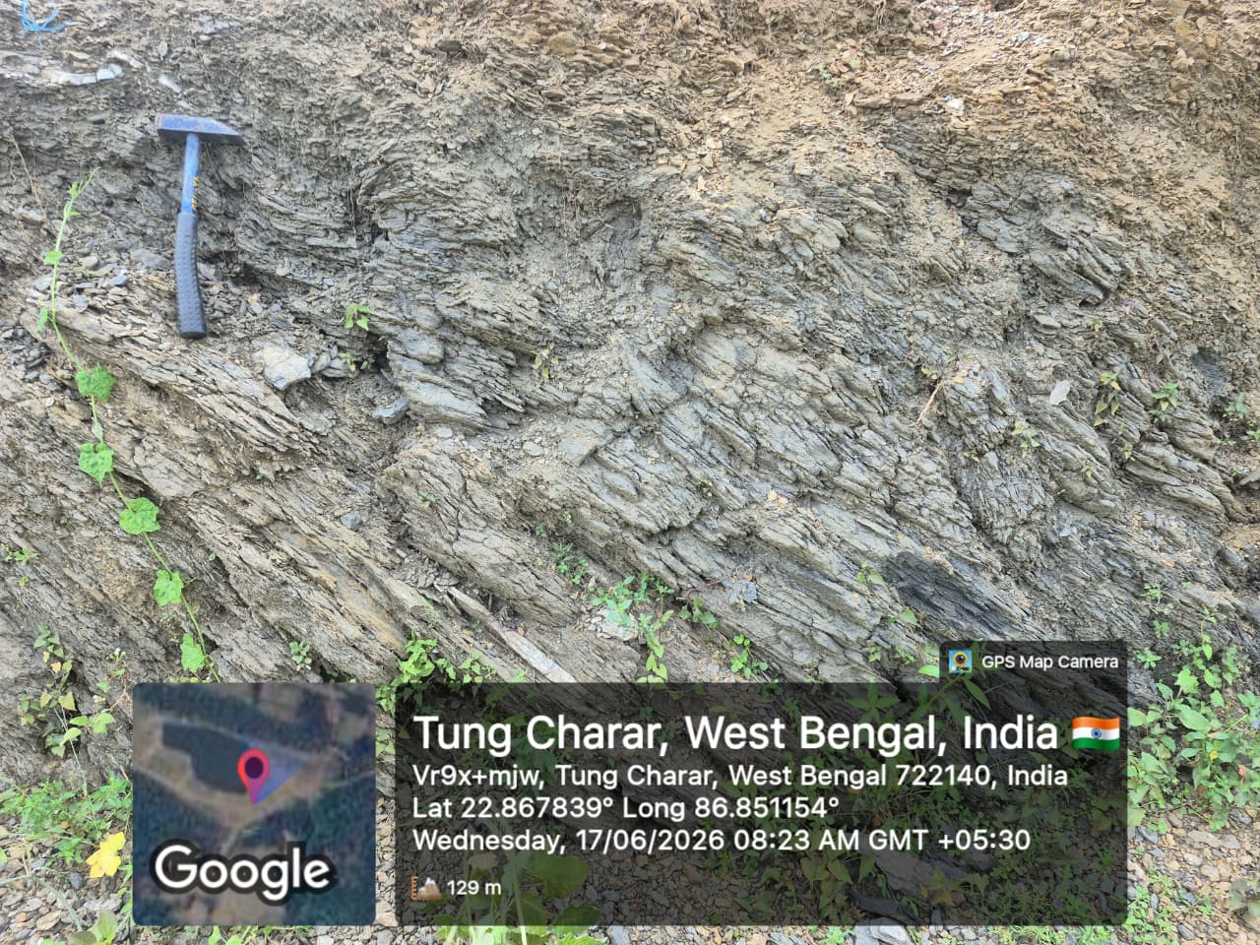

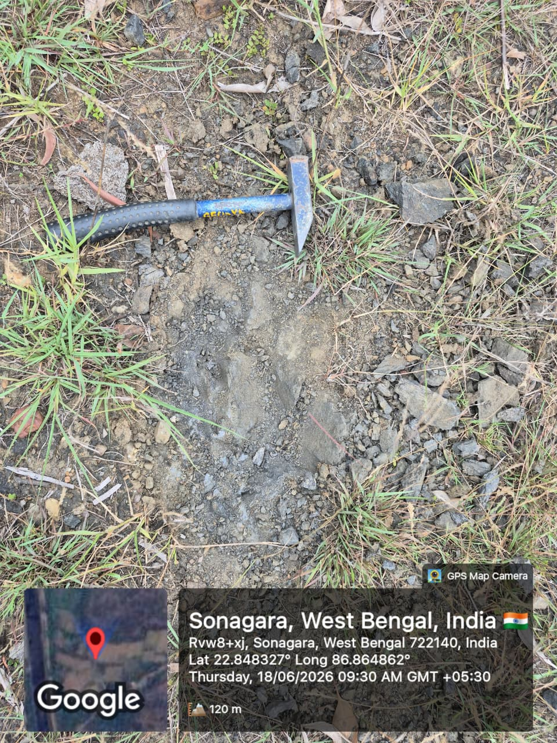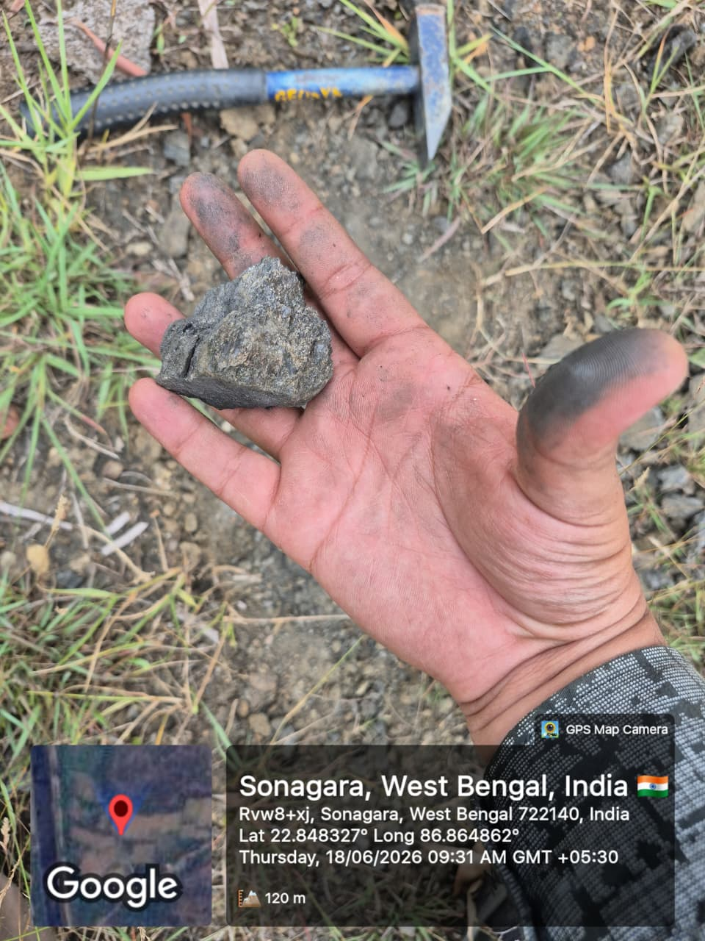
Figure 2: Field Photograph of Graphite bearing mica schist

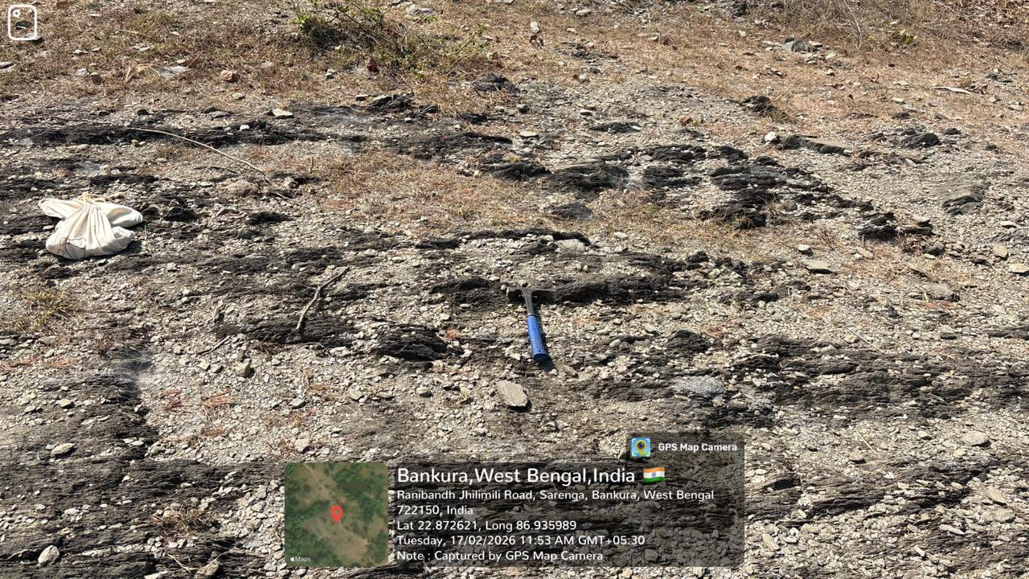

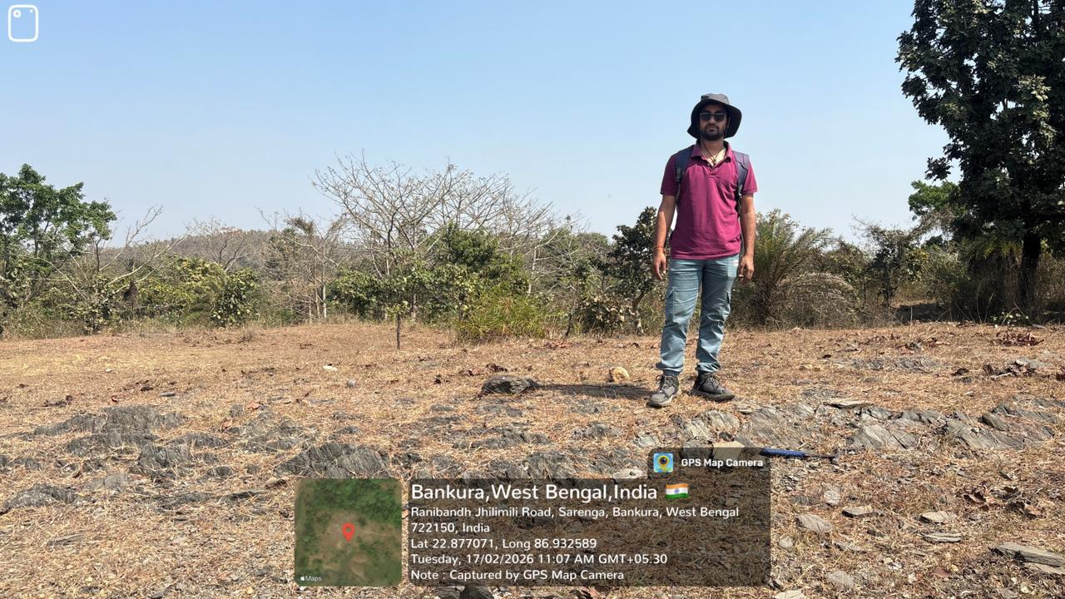
Figure 3: Field photographs

Mineral potentiality based on geology and ground geochemistry etc. carried out by MMPL:
During the field traverses eight numbers of samples collected from in-situ exposures of graphite bearing mica schist. The fixed carbon value varies from 3.83 % FC to 11.89 % FC. The analysis report is given in table 2 and samples locations are shown on the geological map (Figure 3).

Table 2: Result of proximate analysis of nine numbers of graphite bearing samples
Sl. no | Location Number | Latitude | longitude | Lithology | (%) MOISTURE (ARB) | (%) VM  (DB) | (%) ASH  (DB) | (%) S  (DB) | (%) FC  (DB)
1 | SD-01 | 22.87664 | 86.93202 | Graphite bearing schist | 0.67 | 2.94 | 90.64 | 0.11 | 6.31
2 | SD-02 | 22.87212 | 86.93604 | Graphite bearing schist | 0.38 | 2.95 | 91.58 | 0.08 | 5.39
3 | SD-03 | 22.85935 | 86.93275 | Graphite bearing schist | 0.15 | 3.06 | 91.87 | 0.14 | 4.93
4 | SD-04 | 22.86784 | 86.85115 | Graphite bearing schist | 1.41 | 5.13 | 87.62 | 0.21 | 7.04
5 | SD-05 | 22.8678 | 86.85379 | Graphite bearing schist | 2.19 | 7.13 | 88.42 | 0.19 | 4.26
6 | SD-06 | 22.86968 | 86.86188 | Graphite bearing schist | 2.31 | 6.46 | 88.59 | 0.18 | 4.77
7 | SD-07 | 22.84025 | 86.86609 | Graphite bearing schist | 0.21 | 3.06 | 88.8 | 0.2 | 7.94
8 | SD-08 | 22.85763 | 86.87952 | Graphite bearing schist | 2.26 | 6.51 | 81.42 | 0.18 | 11.89
9 | BR-01 | 22.74268 | 86.80944 | Graphite bearing schist | 1.01 | 3.52 | 92.2 | 0.09 | 4.19
10 | BR-02 | 22.74264 | 86.80908 | Graphite bearing schist | 0.94 | 3.63 | 92.33 | 0.07 | 3.97
11 | BR-03 | 22.85193 | 86.80895 | Graphite bearing schist | 1.12 | 4.22 | 91.74 | 0.07 | 3.97
12 | BR-04 | 22.85393 | 86.81081 | Graphite bearing schist | 0.61 | 3.26 | 90.16 | 0.12 | 6.46
13 | BR-05 | 22.83469 | 86.78381 | Graphite bearing schist | 0.18 | 2.41 | 90.30 | 0.14 | 7.15
14 | BR-06 | 22.83832 | 86.78918 | Graphite bearing schist | 0.50 | 3.45 | 92.44 | 0.28 | 3.83
15 | BR-07 | 22.79361 | 86.79667 | Graphite bearing schist | 1.41 | 4.89 | 90.98 | 0.11 | 4.02

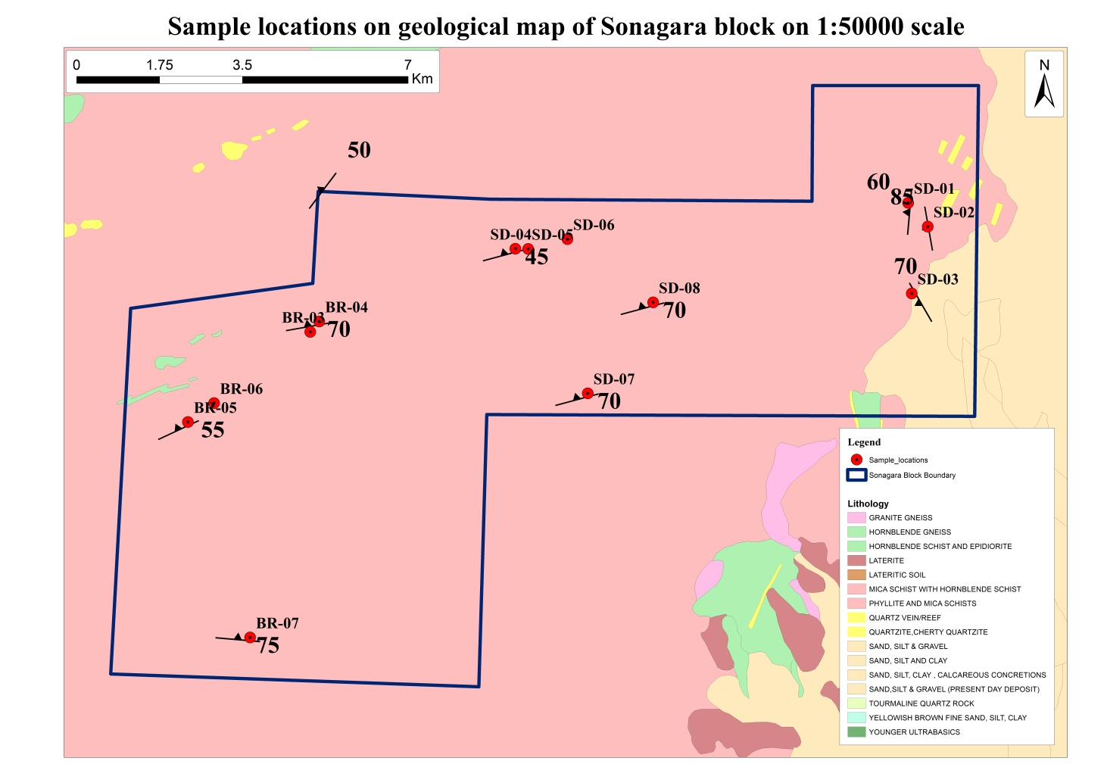
Figure 4: Sample location map of Sonagara block

Scope for proposed exploration:
The present exploration program (G-4 stage) has been formulated on the basis of the outcomes of previous work to fulfil the following objectives:

- Geological mapping on 1:12500 scale to delineate Graphite bearing lithological units and other lithological units in the area.
- Delineation of the potential subsurface mineralized zones by Geophysical Surveys (SP survey).
- Trenching will be carried out to expose for collection and analysis of Graphite bearing lithological units to establish the surface thickness of the mineralization.
- Exploratory drilling to prove the depth persistence of graphite mineralization at 30 m vertical depth of intersection.
- Assessment of quality and quantity of the resources (334) if any as per UNFC norms & Minerals (Evidence of Mineral Contents) Rules- 2015.

Justification for taken up the exploration programme:
Justification for taking up the investigation in G4 stage:
- Mr. Sudipta Lahiri and Mr. Bhupendra Singh (GSI, 1990-93) reported occurrence of Graphite sericite schist during STM.
- To the west of the proposed block, in Ranibandh block, Mr. B.P. Yadav estimated a resource of 0.898 million tonne for zone A at 2.15% to 9.69% weighted average FC and 0.483 million tonne for zone B at 3.08%-8.69% weighted average FC during G4 stage of investigation.
Fixed carbon values, for eight numbers of graphite bearing samples collected from the proposed block area of Sabuj Dweep, are ranging from 3.83% FC to 11.89 % FC.

Previous Work on similar geological setting of NSMB:

Lahiri. S and Singh. B (GSI, 1990-93) specialised thematic mapping of the area between dalma volcanics and the tamar-porapahar shear zone in parts of Medinipur, Purulia and Bankura districts, west Bengal.

Yadav. B.P. (MMPL, 2024-25) carried out reconnaissance survey of graphite in Ranibandh block, bankura district, West Bengal.

Block description
The name of the proposed block is Sonagara block, situated in Bankura district of West Bengal falling on Survey of India Toposheet number 73J/13. The area of the proposed block is 125.43 Sq.km. Co-ordinates of the cardinal points of the block is given below-
Point | Latitude | Longitude
A | 22.8990 | 86.9123
B | 22.8769 | 86.9122
C | 22.8787 | 86.8105
D | 22.8564 | 86.7772
E | 22.7866 | 86.7680
F | 22.7843 | 86.8437
G | 22.8362 | 86.8453
H | 22.8359 | 86.9457
I | 22.8990 | 86.9465

Planned Methodology
In accordance with the objectives set for reconnaissance survey (G4 level of exploration) in SONAGARA BLOCK large scale geological mapping on 1:12500 scale, trenching, bed rock and trench sampling, geophysical and geochemical survey and exploratory drilling are proposed to be carried out to delineate the graphite mineralised. The exploration will be carried out as per Minerals (Evidence of Mineral contents) Rules-Amended in 2021. Accordingly, the details of different activities to be carried out are presented in subsequent paragraphs.

DGPS Surveying
The reduced level and coordinate of the boreholes would be surveyed by DGPS/ total station.

Geological Mapping
Geological mapping (LSM) on 1:12500 scales in the area (76.19 Sq. Km) will be carried out by taking geological traverses. The contacts of different lithological units, surficial lithology, structural features, etc. will be noted in detail. The geological map on 1:12500 scale will be generated based on the details gathered during the field visit.

Core Drilling
6 numbers of scout boreholes are proposed to be drilled to establish the depth continuity of graphite mineralization up to a vertical depth of 30 m.

Borehole plan:
Drilling will be done based on potential surface geological, geochemical and geophysical evidences.

Core Logging
The drill cores would be logged systematically viz. details of lithological-units, colour, structural feature, texture, mineralization, beside the recovery, rock quality designation and type ore deposit would be recorded.

Core Sampling
The drill core will be split into two equal halves and one part would be preserved in the core box. The other half will be powdered to -200 mesh sizes and the same would be divided into four parts (250 g each) through coning and quartering. One part of 250 g sample will be sent to chemical laboratory for analysis, second part to be preserved in the camp as duplicate sample, third part to be utilized for preparing composite sample for individual ore band and the fourth part would keep as either check sample or sample to be used for any other specific purpose.
The length of each sample will be kept 0.50 m-1.0 m depending upon the width of and physical character of the mineralization.

Petrographic & Mineralographic Studies
Thin and polished section studies of the outcrop samples and the core samples will be studied for detailed petrographic and mineralographic characteristics. These samples will be drawn from ore zones and associated rocks. A provision of 10 nos. specimens (5 nos. from BRS and 5nos. from Cores) for petrographic and 10 nos. specimens for mineralographic studies has been kept for the proposed area.

Bulk Density Determination
In addition, bulk density determination of 5 nos. of graphite bearing samples will be carried out for the proposed block for resource estimation.

Nature Quantum and Target for G4 stage
Quantum of work proposed for reconnaissance survey of Graphite in SONAGARA BLOCK, Bankura district, West Bengal are given below-

S.No | Nature of Work | Unit | Tentative quantum to be proposed | Justification
1 | Geological mapping (LSM on 1:12500) (sq km) | sq. km | 125.43
2 | Survey work-
 | b) DGPS survey for fixation of borehole points | Point of observation | 8
3 | Geophysical SP survey | L.km | 10
4 | Technological survey
 | a) Surface exploration-Trenching (cu. m) | Cu m | 100 | 10 trenches of dimension 10m×1m×1m
 | b) Sub surface exploration – Drilling (m) | Per m | 500 | 8 numbers of boreholes with 60 m borehole length each with 20 m buffer
5 | Geochemical survey
 | a) Bed rock samples | Nos. | 100
 | b) Trench samples | Nos. | 80
 | c) Core samples (nos.) | Nos. | 160 | Considering 20 m mineralization in each boreholes (8 boreholes)
6 | Petrographic/ mineralographic studies
 | a)Preparation of thin section | Nos. | 10 | 5 from BRS, 5 from core
 | b) Ore microscopy (both under reflected and transmitted light) | Nos. | 10
 | c) Sp. Gravity/ Bulk density (nos.) | Nos. | 5
7 | Chemical analysis
 | a) Proximate analysis |  | 340 | BRS+Trench samples+core samples = 100+80+160
 | b) ICPMS studies | Nos. | 50 | To check the availability of REE elements if any
 | c) Proximate analysis (10% external check) | Nos. | 34
 | d) Total graphitic carbon | Nos. | 10 | To validate that FC% in proximate analysis is the actual graphitic carbon content
 | e) Petrochemical studies | Nos. | 10 | To validate the outcome of petrographic study

Manpower deployment
Two geologists, two geophysicists, one surveyor with required laborers and one drilling rig with drilling crew will deployed as per the requirement of the time schedule chart.

Break-up of expenditure

Estimated Cost for Reconnaissance survey (G-4 stage) of Graphite in Sonagara block, Bankura district, West Bengal
Total area - 125.43 Sq.km; Borehole - 8 ; Meterage - 500 m , Period of completion - 12 months, Review - After 6 months (Mid-term review) and 9 months (Final review)
SL.No | Item Of Work* | Unit* | Rate As Per NMET SOC 2020-21 |  | Estimated Cost of the Proposal
SL.No | Item Of Work* | Unit* | SOC. Item No | Rate As Per revised SOC* (a) | Qty. (b) | Total  Amount  (Rs) (a*b) | Justification/ Remarks
A | Detailed Geological Mapping Other Geological Work & Surveying
i | Large Scale Geological mapping on 1:12500 scale including surface outcrop sampling and trench sampling | Per Sq.km | 1.1 | ₹ 18,300.00 | 125.46 | ₹ 22,95,918.00
ii | a. Charges for 2 Geologist per day (Field) for Geological mapping & Trenching work, drilling activity (without labour) | day | 1.2.1a | ₹ 14,500.00 | 150 | ₹ 21,75,000.00
iii | b. Labours charges; Base rate (for 2 labours per geologists) | day | 5.8 | ₹ 541.00 | 300 | ₹ 1,62,300.00 | As per SoC
iv | c. Charges for Geologist per day (HQ) | day | 1.2.1a | ₹ 10,500.00 | 60 | ₹ 6,30,000.00 | 35 days for geological report preparation and associated plates, 5 days for incorporation of suggestions after peer review, 5 days for preparation of core repository documents and NGDR portal related documents, 15 days for geological report printing, binding, submission to concerned authority
 | Sub Total- A |  |  |  |  | ₹ 52,63,218.00
B | Trenching/Pitting
i | Trenching | per cu.m | 2.1.1 | ₹ 4,125.00 | 100 | ₹ 4,12,500.00 | 10 numbers of trenches of dimension 10m×1m×1m.
 | Sub Total- B |  |  |  |  | ₹ 4,12,500.00
C | Survey work
i | DGPS Survey for BH fixation & RL determination | Per Point of observation of observation | 1.3.2 | ₹ 24,000.00 | 6 | ₹ 1,44,000.00 | 6 numbers of boreholes
 | Sub Total- C |  |  |  |  | ₹ 1,44,000.00
D | Ground Geophysical Survey (in- house)
i | Charge for SP survey | Per L.km | 3.3a | ₹ 62,140.00 | 10 | ₹ 6,21,400.00
 | Sub Total- D |  |  |  |  | ₹ 6,21,400.00
E | Drilling (after review) (in-house)
i | Systematic Drilling (hard rock) (HQ) | per m | 2.2.1.1d | ₹ 10,000.00 | 500 | ₹ 50,00,000.00 | 8 nos of boreholes (60 m borehole length each) with 20 m Buffer
ii | Land / Crop Compansation (in case the BH falls in agricultural Land) | per borehole | 5.6 | ₹ 30,000.00 | 8 | ₹ 2,40,000.00
iii | Construction of concrete Pillar (12"x12"x30") | per borehole | 2.2.7 | ₹ 2,000.00 | 8 | ₹ 16,000.00
iv | Miscellaneous charges (Transportation of drilling rigs, accomodation for drilling camp, camp setting and winding construction of approach road making and drill core preservation) | Lumpsum | 2.2.9 | Drilling cost less than 50 lakh : 25% of the drilling cost |  | ₹ 12,50,000.00
v | Charges for one Sampler per day (1 Party) | one sampler per day | 1.2.1b | ₹ 7,850.00 | 45 | ₹ 3,53,250.00 | 15 days for BRS and PT samples (Sample preparation by crushing and powdering) , 30 days for core samples (half spitting, sample crusing and powdering)
vi | Charges for Labour | day | 5.8 | ₹ 541.00 | 180 | ₹ 97,380.00
 | Sub Total- E |  |  |  |  | ₹ 69,56,630.00
F | Laboratory Studies
1 | Chemical Analysis
i) | Surface Samples
a | Proximate analysis | Nos | 4.1.18 | ₹ 3,614.00 | 100 | ₹ 3,61,400.00
b | Proximate analysis (10% external check) | Nos | 4.1.18 | ₹ 3,614.00 | 10 | ₹ 36,140.00
ii | Trench Samples
a | Proximate analysis | Nos | 4.1.18 | ₹ 3,614.00 | 80 | ₹ 2,89,120.00
b | Proximate analysis (10% external check) | Nos | 4.1.18 | ₹ 3,614.00 | 8 | ₹ 28,912.00
iii) | BH Core samples
a | Proximate analysis | Nos | 4.1.18 | ₹ 3,614.00 | 160 | ₹ 5,78,240.00 | Considering intersection of 20 m mineralization in each borehole
b | Proximate analysis (10% external check) | Nos | 4.1.18 | ₹ 3,614.00 | 16 | ₹ 57,824.00
c | Analysis by ICPMS (14 REE + 9 Trace element) | Nos. | 4.1.15 | ₹ 7,400.00 | 50 | ₹ 3,70,000.00 | To check the availability of REE elements associated with graphite if any
d | TGC analysis | Nos. |  | ₹ 3,500.00 | 10 | ₹ 35,000.00 | To validate that FC% in proximate analysis is the actual concentration of graphitic carbon
e | Raman Spectroscopy | Hrs. | 4.5.1 | ₹ 2,700.00 | 8 | ₹ 21,600.00
2 | Physical & Petrological Studies
i | Preparation of Standard thin section of rock | Nos | 4.3.1 | ₹ 500.00 | 10 | ₹ 5,000.00 | 5 BRS samples, 5 Core samples
ii | Complete petrographic/ ore microscopic study/ mineragraphic report of rock sample (along with 5 nos. digital photo micrograph) | Nos | 4.3.4 | ₹ 2,800.00 | 10 | ₹ 28,000.00
iii | petrochemical studies | Nos | 4.1.17a | ₹ 4,200.00 | 10 | ₹ 42,000.00 | To validate the petrographic analysis by chemical analysis result
iv | Bulk density analysis | Nos | 4.8.3 | ₹ 2,500.00 | 5 | ₹ 12,500.00
v | Drill core preservation | per m | 5.3 | ₹ 1,590.00 | 160 | ₹ 2,54,400.00 | Stratigraphic borehole - 60 m + Mineralised zone with bounding country rock - 100 m (20 m each for 5 boreholes)
vi | 3D ore body modelling with compatible software | As per actual | 5.4 |  |  | ₹ 8,00,000.00 | To validate the resource which will be estimated by cross sectional area method
 | Sub Total- F |  |  |  |  | ₹ 29,20,136.00
G | Total A to F |  |  |  |  | ₹ 1,63,17,884.00
H | Geological Report Preparation | 5 Hard copies with soft copy | 5.2 | total cost of project exceeding 150 lakh |  | ₹ 7,50,000.00 | Reimbursement will be made after submission of the Final Geological Report in Hard Copies (5 Nos) and the soft copy to NMET.
I | Peer review Charges | As per EC decision |  | ₹ 30,000.00 | 1 | ₹ 30,000.00
J | Preparation of Exploration Proposal (5 Hard copies with a soft copy) | 5 Hard copies with a soft copy | 5.1 | 2% of the Cost or Rs. 5 Lakhs whichever is lower |  | ₹ 3,41,357.68 | EA will be reimbursed after submission of the Hard Copies and the soft copy of the final proposal along with Maps and Plan as suggested by the TCC-NMET in its meeting while clearing the proposal.
K | Total Estimated Cost without GST |  |  |  |  | ₹ 1,74,39,241.68
L | Provision for GST (18% of L) |  |  |  |  | ₹ 31,39,063.50 | GST will be reimbursed as per actual and as per notified prescribed rate
M | Total Estimated Cost with GST |  |  |  |  | ₹ 2,05,78,305.18
M | Rs. In Lakhs |  |  |  |  | ₹ 205.78

Time schedule

Time Schedule/Action Plan for reconnaissance survey (G4 stage) in Sonagara Block, Bankura district, West Bengal under NMEDT
S.No | Nature of Work | Proposed Quantum | Months
S.No | Nature of Work | Proposed Quantum | 1 | 2 | 3 | 4 | 5 | 6 | REVIEW | 7 | 8 | 9 | 10 | 11 | 12
1 | Camp Set up |  |  |  |  |  |  |  | REVIEW
2 | Geological mapping on 1:12500 scale (LSM) (sq. km) | 76.19 Sq.km |  |  |  |  |  |  | REVIEW
3 | Geophysical SP survey | 10 L.km |  |  |  |  |  |  | REVIEW
4 | Surface exploration- Trenching | 100 |  |  |  |  |  |  | REVIEW
5 | Proximate analysis of surface samples | 198 Nos. |  |  |  |  |  |  | REVIEW
7 | DGPS survey for fixation of borehole points | 6 Nos. |  |  |  |  |  |  | REVIEW
8 | Drilling of Scout boreholes | 500 m |  |  |  |  |  |  | REVIEW
10 | Proximate analysis of subsurface samples | 176 Nos. |  |  |  |  |  |  | REVIEW
11 | Geological report preparation, peer review and submission |  |  |  |  |  |  |  | REVIEW

List of Plates

Plate 1: Proposed boundary of Sonagara Block on Survey of India toposheet number 73J/13
Plate 2: Geological map of Sonagara Block on 1:50000 scale
Plate 3: Sample locations on Geological map of Sonagara Block on 1:50000 scale

