PROPOSAL FOR UNDERTAKING PRELIMINARY EXPLORATION (G3 STAGE) OF GRAPHITE AND ASSOCIATED MINERALS IN CHADRANGA AREA (4.40 SQ. KM), DISTRICT-RAYAGADA, ODISHA

(Commodity: Graphite)

By
EARTENVIRO LAB PRIVATE LTD
BHUBANESWAR

Place:BHUBANESWAR

The 3rd Joint meeting of Technical Cum-Cost Committees (both TCC-I & TCC-II) of National Mineral Exploration and Development Trust (NMEDT) was held on 4th September, 2025 through video conferencing to allocate 51 nos. of blocks identified from the legacy reports of state DGMs/DMGs among various exploration agencies for upgradation through NMEDT Fund.

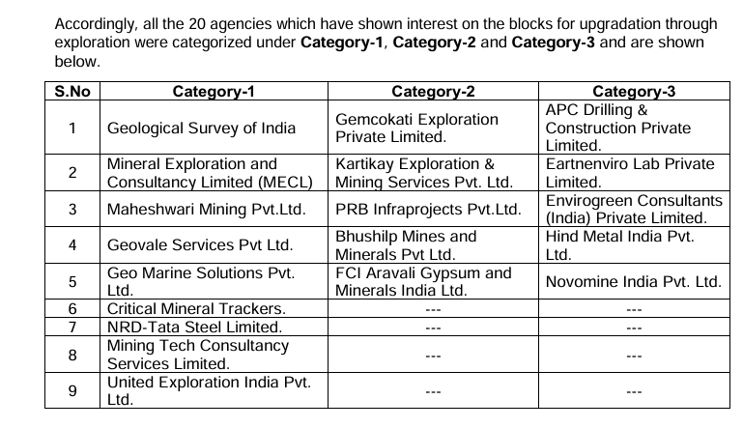

Two Reports have been allotted to M/s Eartnenviro Lab pvt. Ltd.

1. Report on Investigation for Graphite around Maguni In Gunupur Sub-Division of Rayagada District, Orissa.
2.Report on the investigation of limestone around Dumajodi Kondajodi in Koraput district, Odisha.

Present Report is dealing with “Investigation for Graphite around Maguni In Gunupur Sub-Division of Rayagada District, Orissa.”
The area was visited by ELPL Geologists after studying the literature , Reports of the area. It was found that 4.4 sq. km area in and around Chadranga village has no. of outcrops of Graphite for which G3 Exploration programme has been formulated. Further, technically it was discussed and the project was approved in 98th TCC-I Meeting held on 10/06/2026. Further 10th PSC held on 29/06/2026 approved the proposal with the cost involvement of Rs. 20,226,426.00.

Back Ground:
As per the annual field programme the area around Maguni in Bissam – Cuttack Tahasil of Gunupur sub-division was taken up for investigation during the field season 1990-91. The investigated area is featured in survey of India Toposheet No. 65M/5 and 65M/6 and falls between latitude 19°40’ to 19°47’ 30’’ and longitude 83° 25’ to 83° 30’.

The area under report is featured by the Eastern-ghat super group of rocks comprising of Khondalites, quartzite’s, granulites, granite-gneiss and migmatites. The area has been partly affected by granitic activity but the dominant formations are khondalites and quartzites, which are frequently associated with granulites. Occurrences of pegmatites and vein quartz bodies are also noted. The general strike of foliation of the formations range from N10° W-S 10°E to N20° E-S 20°W with sub vertical to vertical dips.
During the course of investigation by DMG, Odisha , 15 new graphite occurrences were located around Bijabandali, Chhadranga, Pajibali, Asuraparha , Kansari, Sarabali, Sunakhunti Dhepagurha and Dambesi. Out of these Bijabandali, Sunakhunti and Dambesi are significant as the graphite is of high grade Pajibali and Chhadranga graphite occurrences are inferior the fixed carbon content ranging from 4.83° % to 20.80%.
Apart from graphite, 8 pegmatite bodies, 4 vein quartz, 5 Manganese occurrences (both old workings and new) have been brought to light by DMG, Odisha. The Latagurha and Hatadahikhal quartzites and pegmatites are importants for semiprecious garnet (fractured and friable type).

Accordingly Field visit was conducted by M/s Eartnenviro Lab pvt. Ltd. during February 2026.

It was noticed that a total six G3 blocks can be carved out from this area out of which one DPR for Chadranga is present below-

Chadranga Graphite Block for G- 3 Level Exploration

Sl. No. | Features | Details
 | Block ID | Chadranga Graphite Block
 | Current Exploration Agency | Eartnenviro Lab Pvt. Ltd.
 | Previous Exploration Agency
 | Previous stage Geological Report | G-4 level GR of DGM attached in Annexure-I.
 | Commodity | Graphite
 | Mineral Belt | Eastern Ghats Mobile Belt, Rayagada District,  Odisha
 | Completion Period with entire Time schedule to complete the  project | 12months
 | Objectives | DGM, Odisha has undertaken G4 investigation. They have found strata bound graphite deposit. Qtz-Garnet-Sillimanite-graphite schist/Gneiss is the host rock for Graphite.  G3 Exploration is required in and around Chadranga village where maximum exposure of Graphite are visible in field.
 | Whether the work will be carried out by the proposed agency or throughout sourcing and details there of. Components to be out  Sourced and name of the out sourceagency | Geological and Geophysical and Laboratory work will be done in house and Drilling work will be carried out through Outsourcing Agency.

 | Name/Number of Geoscientists | 3 Geoscientists
 | Expected Field days (Geology, Geophysics, Surveyor) | Geologist Party days: 150 days  Geophysical Partydays:20days  Survey Party days: 25days
1. | Location | Chadranga Block
1. | Latitude | 19⁰40’ 56.8” N to19⁰ 43’03.9”N
1. | Longitude | 83⁰ 26’57.9” E to 83⁰28’09.1” E
1. | Villages | Chadranga.Bijabandli,Pajibali,Sarabali,Maguni
1. | Tehsil /Taluk | Rayagada
1. | District | Rayagada
1. | State | Odisha
2. | Area(hectares/squarekilometres)
2. | Block Area | 4.40Sq km
2. | Forest Area | Land schedule under collection.
2. | Government Land Area | Land schedule under collection.
2. | Private Land Area | Land schedule under collection.
3. | Accessibility
 | Nearest Rail Head | Muniguda on East Coast Railway
 | Road | Rayagada- Bhawanipatna Road , over a distance of 2 kms from Hata Dahikhal which lies at a distance of 12kms from Muniguda
 | Airport | Visakhapatnam, the nearest port is at 304 km.
4. | Hydrography
4. | Local Surface Drainage Pattern (Channels) | The area exhibits dendritic to sub dendritic drainage pattern .
4. | Rivers/Streams | The river Vasundhara flows in the eastern part of the area
5. | Climate
5. | Mean Annual Rainfall | 1285mm
5. | Temperatures (December) (Minimum)  Temperatures (May)(Maximum) | December:13⁰Cto14⁰C  May: 35⁰C
6. | Topography
6. | Toposheet Number | 65M/6
6. | Morphology of the Area | The area in generally represents a rugged topography with high elevation ranges. The eastern parts of the terrain are occupied by dense and hilly forests.
7. | Availability of baseline geosciences data
7. | Geological Map (1:50K/25K) | Available Geological Map 1:25000scale
7. | Geochemical Map | Not Available

 | Litho-structuralMap | Not Available
8. | Justification for taking up G3 stage mineral exploration | 1.Graphite occurrence has been established by DGM, Odisha under G4 matrix of UNFC during 1990-1991.  2.Based on the occurrence of Graphite, Surface exposures, the vein continuity will be established after mapping & G3 level exploration.  3.Preliminary exploration required to know the vertical & lateral continuity of the ore body and its reserve in 333 category as per MEMC rule, 2015.  4.Graphite is a critical mineral for the nation. Hence its exploration will augment the total mineral reserve as well as its use in modern civilization.

PROPOSAL FOR CHADRANGA BLOCK, RAYAGADA DISTRICT, ODISHA STATE FOR G-3 STAGE MINERAL EXPLORATION UNDER NMEDT

Introduction

Systematic exploration for graphite has been carried out by the Directorate of Mining and Geology , Orissa. Examination of parts of Bissam-Cuttack tahsil in the Gunupur Sub-division of Koraput district (Now Under Rayagada District) was taken up during 1990-91 field season as a continuation of the investigation programme. An area of 75 sq.km was covered by systematic geological mapping on 1:25000 Scale.

During the course of investigation 15 graphite occurrences were located around Bijabandali ,chhandranga, pajibali, Asuraparha, Kansari, Sarabali, Sunakhunti, Dhepagurha and Dembesi. Trial excavation was done in the graphite occurrences to ascertain their extension was made.

Physiography &Drainage:

The area covered by exploration bordering Kalahandi district consists mostly of hills with minor plane land. Dense vegetation mainly featuring sal marked in the SW, NE and SE portion of the area. The area has attained a maximum height of 968 metres and the valleys are formed at an average height of 350 meter from the M.S.L.

The river Vansadhara flows in the eastern part of the area under report. Panimunda, Karanjanadi, Golangabandhanadi are the principal tributaries of river Vansadhara. Panimundanadi flows in NE direction and Golangabandha nadi flows NW-SE and they have come together with river Vansadhara almost near Barha- Siringul and Dekadumari. The river Vansadhara and its tributaries control the drainage of the area. The area exhibits dendritic to sub dendritic drainage pattern. Numerous streams and streamless flowing from the hills and hillocks in all possible direction discharge their water to the river Vansadhara and its tributaries which are perennial in nature.

.

Climate:

The area experience a moderate climate, monsoon starts from the month of May and continuous up to the middle of September .
Regional Geology of the area:
The area forms a part of the highly metamorphosed Easternghat super group rocks. The major rock types include Khondalites, Quartzites, granulites, granite gneiss, charnockites and migmatised Khondalites. The original country rock has been metamorphosed to granulite facies. Lithological units like pyroxene-plagioclase , granulite/ pyroxene, granulite/hornblende , granulite are found in the area. Khondalites and its variants are seen in high hills bordering kalahandi district. Occurrences of quartzite’s are seen in the planes and as dome shaped hillocks. Part of the area is affected by granitic activity. Migmatites are partly developed . Graphite is characteristically associated with migmatised khondalites. The western block of the area under report dominated by khondalite and quartzites area stretching from Mohanpur to kathubarhi in a NNE- SSW direction. However , migmatites are marked near Pajibali and Dhepagurha area. Occurrence of pegmatites and vein quartz bodies are also noted.
A generalized sequence of the litho-units of the area may be given as follows:-
Archaean | Intrusives - | Alluvium and Soil
Archaean | Older Metamorphics  (Eastern Super Group) | Vein Quartz, Pegmatite, Migmatite  Granulites/ Pyroxene, Plagioclase granulite/ Hornblende Granulite  Granite gneiss/ Hornblende plagioclase gneiss  Quartzites
Archaean |  | Khondalites

A brief note on the different litho-units of the area is given below

Khondalite:

Khondalite is the oldest rock in the area. It exhibits a wide range of compositional variation mostly represented by Quartz- Feldspar-Garnet – Sillimanite with or without graphite. Sillimanite are arranged in bands where as garnets area seen as aggregates of rounded and sub rounded grains with abundant cracks. Garnets are often altered to iron oxides. At a number of places khondalites are granitised and weathered to a great extent. Intense weathering of khondalites is well marked near Panimundanadi. Graphite is confined in the foliation plane of khondalites. Foliation in khondalite strike N10º W-S10ºE in Chandranga.

Quartzite:

Outcrops of Quartzite are seen near Hatadahikhal, Latagurha, Sibapadar, Hatipadar ,Mohanpur, Durkilima and Sunakhunti areas. In latagurha and Hatadahikhal areas quartzites are sheared due to diastropic movements and show banding. Fractured and friable variety of semiprecious garnets are seen in quartzites of Latagurha and hatadahikhal area. Quartzites are white grey in colour and devoid of mica. They trend N20º E-S20ºW with 40º southeasterly dip. 400 meters south of Kathubarhi manganese is found in quartzites.

Granite- Gneiss:
Granite gneiss occurs west of Barha Dahikhal and south east of Hatipadar areas. It exhibits a wide range of mineral composition and textural variations. The dominant minerals are hornblende ,plagioclase , diopside, garnet an biotite mica. To the southwest of Khalugurha the rock shows granoblatic texture and is coarse grained. Granular quartz and feldspar are the predominant minerals.

Charnockite :
Small patches of charnockite are reported near Perrigurha, Sunakhunti, east of Dhepagurha and 500 meter east of Dhepagurha and 500 meter east of Kebarhatula village. The dominant mineral present is hypersthenes with subordinate diopsite and biotite mica.

Granulites:
Granulites are seen near Sitapuram and kebartulaarea. These are composed of quartz, feldspar, biotite and garnet. Pyroxene granulite and Biotite – hornblende granulite are also seen.

Migmatites :
Khondalites are granited to a great extent and give rise to granitised khondalites and migmaties . The trend of the foliation are same as kondalitic rocks. Migmatite shows ptygmatic folding and are reported south west of Pajibali, north of barha Dahikhal and east of Dhepagurha.

Exploration :
During the course of the investigation 15 graphite occurrences were brought to light around Bijabandali, Chadranga, Pajibali, Kansari, Asuraparha, Sunakhunti and Deppagurha. Trial excavations of 410 cubic meters were done.

Mineralisation Details:
Exposures of graphite gneisses are encountered in the Nala section. The fixed carbon varies from 29.50 to 30.72%. It is a vein type deposit. The enrichment of graphite has taken place over a width of 30 mt. The graphite was found concealed within 3 meter soil cover. During geological mapping, it was noticed from the nala wall sections that, both migmatised khondalite & quartzo feldspathic gneiss occur concomitantly & graphite mineralisation is restricted only to the contact zones (more pronounced in the hanging wall side of quartzo - feldspathic gneiss & less often in the foot wall).
Graphite is confined to the foliation plane of khondalites. It occurs as disseminations in the form of minute flakes along the foliation plane of migmatised khondalites. The graphite is of crystalline and flaky nature and black in colour.
The graphite occurs in 96 samples drawn from the area have been chemically analysed and 14 rock samples have been petrologically studied. The deleterious minerals present are Khondalites, quartzites, granulites, migmatised khondalites, migmatites, granite-gneisses. Migmatite shows ptygmatic folding and graphite mineralisation is confined mostly to the foliation plane of khondalites whereas manganese mineralisation is restricted to khondalites and quartzites. The dominant minerals are hornblende, plagioclase, diopside, garnet and biotite mica.Manganese mineralisation is confined to khondalites and quartzites.

Scope for proposed exploration:

Out of 15 graphite occurrences around Bijabandali, Chhadranga, Pajibali, Kansari ,Asuraparha, Dambesi ,Sunakhunti and Deppagurha 11 occurrences have taken into account for G3 Exploration having 4.40 sq. km Area . Lateral continuity up to depth 60m will be proved along with resource estimation .

Objectives:
The present exploration programme has been formulated in accordance with the previous work carried out by DGM(O) and also as per Mineral (Evidence of Mineral Contents) (MEMC) Rule-2015 & Mineral (Auction) Rule-2015 to fulfill the following objectives:-
Objective of the proposed Exploration is to carry out G-3 level exploration work in the block to make it auction worthy:
- To carry out detailed geological mapping & validate the Geological map on 1:4000 scale and demarcate the rock types of Graphite bearing formations with the structural features.
- To carryout Geophysical Survey
- To drill boreholes in the 200 x 200m section interval as per MEMC Rule 2015.
- To drill boreholes to prove depth continuity up to 60m depth from the ground level.
- To estimate Graphite ore resources (333) in the block as per UNFC norms of Mineral (Evidence of Mineral Contents) Rules- 2015 & Amendment Act 2021.

Block description:

The description of Chadranga Block is given below in the Table No-1.

TableNo-3.1

Chadranga Block
Block corner points/ Cardinal Points | Longitude | Latitude
A | E83⁰ 26’ 57.9” | N19⁰ 42’ 54.7”
B | E83⁰ 29’ 39.0” | N19⁰ 43’ 03.9”
C | E83⁰ 28’ 09.1” | N19⁰41’ 03.0”
D | E83⁰ 27’ 32.1” | N19⁰ 40’ 56.8”

- Planned Methodology:
In order to achieve the objectives set for Preliminary Exploration (G-3) in Chadranga Block,Rayagada District, Odisha, Surveying, detailed geological mapping, geophysical survey and drilling programme along with sampling and analytical work is proposed in the block. The exploration shall be carried out as per Mineral (Evidence of Mineral Contents) Rule-2015 .
Accordingly, the details of different activities to be carried out are presented in subsequent paragraphs. Initially it is proposed to drill at least 10 nos BHs.

Topographic Surveying:

Topographical survey will be carried out in the block area. All the surface features will be picked up and marked on a map on 1:4000 scale. The prospect area would be tied up with the triangulation network. The reduced levels and co-ordinates of boreholes would be determined. The locations of the trenches and pits will be surveyed. The block boundary will be surveyed by DGPS & total station in WGS-84 Datum for demarcation of Block Boundary points.

Geological Mapping:

The detailed geological mappings on 1:4000 scale will be carried out in the block around 4.40Sq km by taking geological traverses in the block. The contacts of different formations, identification of different rock formation, structural features, etc., will be carried out in detail. The geological map on 1:4000 scale will be generated based on the detail geological mapping of the block along with contouring at 4 m interval through Topographic Survey.

Pitting & Trenching:
pits of 1m x 1m x 2m are proposed to expose the ore body along the strike & dip of the ore zone involving 70 Cu.m of excavation before putting BH points. Similarly Trenches of x 1m x 2 x 8m are proposed to expose the ore body along the strike & dip of the ore zone involving 200 Cu.m of excavation before putting BH points

Geophysical Survey:
Geophysical survey i.e. self-potential survey will be carried out in the entire block along 40 line km(approx.) surrounding the ore zone which covers 30% of the total area(approx.). The geophysical map will be generated based on the SP values recorded in the block. Geophysical interpretation will be provided.

Exploratory Drilling:
Based on the known geology & previous work done geological mapping & Geophysical survey, analytical results of surface, grab samples, channel samples and delineation of Graphite ore body, drilling at grid interval of 200 X200 m is proposed for the known mineralized area. A total of 10 nos. of exploratory boreholes for intercepting graphite lode at 60m in Ist phase & 120m in second phase involving 1200m of exploratory drilling(Diamond core drilling) have been envisaged for G-3 level of exploration. The boreholes have been planned in such a manner that it is presumed to intersect the Graphite ore at deeper levels. In phase I, 1st level boreholes will be planned to investigate the depth persistence of graphite mineralization up to 60 m vertical depths of intersection. The borehole spacing will be 200 X 200 m. In phase II, 2nd level boreholes will be planned based on the reference of 1st level boreholes with positive outcome to investigate the depth persistence of the graphite mineralization at 120 m vertical depth of intersection. It is expected that the Graphite ore band will extend both laterally & vertically along dip direction & subsequent BH planning will be done after mapping. The borehole details are given in the table below and shown on the map (Plate-III).
TableNo-4.1

Details of Proposed Boreholes
SL NO. | PROPOSED BHs | LATITUDE | LONGITUDE | Depth
1 | BH-1 | N19⁰ 41' 46.4" | E83⁰ 27' 27.6" | 79
2 | BH-2 | N19⁰ 41' 49.4" | E83⁰ 27' 26.5" | 79
3 | BH-3 | N19⁰ 41' 52.5" | E83⁰ 27' 25.6" | 79
4 | BH-4 | N19⁰ 41' 53.6" | E83⁰ 27' 29.6" | 66
5 | BH-5 | N19⁰ 41' 51.5" | E83⁰ 27' 33.9" | 66
6 | BH-6 | N19⁰ 41' 57.5" | E83⁰ 27' 31.3" | 66
7 | BH-7 | N19⁰ 41' 57.1" | E83⁰ 27' 54.3" | 79
8 | BH-8 | N19⁰ 42' 00.3" | E83⁰ 27' 53.3'' | 79
9 | BH-9 | N19⁰ 42' 03.3" | E83⁰ 27' 52.0" | 79
10 | BH-10 | N19⁰ 42' 45.3" | E83⁰ 27' 05.2" | 50
11 | BH-11 | N19⁰ 42' 42.4" | E83⁰ 27' 06.9'' | 50
12 | BH-12 | N19⁰ 42' 39.3" | E83⁰ 27' 08.1" | 50
13 | BH-13 | N19⁰ 41' 09.1" | E83⁰ 27' 47.4" | 66
14 | BH-14 | N19⁰ 41' 05.9" | E83⁰ 27' 47.5" | 66
15 | BH-15 | N19⁰ 41' 02.6" | E83⁰ 27' 44.3" | 66
16 | BH-16 | N19⁰ 41' 47.0" | E83⁰ 27' 29.4" | 131
17 | BH-17 | N19⁰ 41' 50.0" | E83⁰ 27' 28.2" | 131
18 | BH-18 | N19⁰ 41' 53.0" | E83⁰ 27' 27.1" | 131
19 | BH-19 | N19⁰ 41' 57.9" | E83⁰ 27' 32.9" | 127
20 | BH-20 | N19⁰ 41' 54.1" | E83⁰ 27' 31.1" | 127
21 | BH-21 | N19⁰ 41' 52.0" | E83⁰ 27' 35.6" | 127
22 | BH-22 | N19⁰ 42' 03.8" | E83⁰ 27' 53.5" | 113
23 | BH-23 | N19⁰ 41' 02.6" | E83⁰ 27' 47.4" | 124
24 | BH-24 | N19⁰ 41' 05.8" | E83⁰ 27' 49.7" | 124
25 | BH-25 | N19⁰ 41' 09.1" | E83⁰ 27' 49.6" | 124
26 | BH-26 | N19⁰ 42' 39.8" | E83⁰ 27' 09.9" | 132
27 | BH-27 | N19⁰ 42' 42.8" | E83⁰ 27' 08.5" | 132
28 | BH-28 | N19⁰ 42' 45.7" | E83⁰ 27' 06.8" | 132

Pit & Grab sampling:
Random picked samples and channel samples will be collected from the graphite deposits.
- Random samples will be collected from the unexplored graphite occurrences.
- Channel samples representing maximum 1cm. Thickness will be drawn from the pits and trenches.
The Samples will be powdered to minus 100 mesh and reduced by coning and quartering for deposits to the analytical laboratory.

Core Logging:
The borehole cores would be logged systematically. Viz. details of the litho units, colour, structural feature, texture, mineralization, core recovery and Graphite ore type would be recorded.

Core Sampling:
The mineralized part of drill core will be sampled as primary sample. The individual sample will be split into two equal halves and one part will be preserved in the core box for future reference and will be stored in core library, after completion of the project. The whole samples shall be splitted through coning and quartering in field. One part will be analysed as primary samples and second part will be preserved in the camp as duplicate sample, third part will be utilized for preparing composite sample for individual ore band and the fourth part will be kept as either check sample or sample to be used for any other specific purpose. The length of each sample will be kept 1m within the ore zone depending upon the width of particular type of Graphite ore and its physical character. The primary core samples will be analysed for 4 radicals i.e( Ash, FC ,VM and Moisture).

The samples will be powdered to minus 100 mesh and reduced by coning and quartering for despatch to the analytical laboratory. Total 445 samples including BRS, Channel, Pit, Trench, BH will be drawn from the area and borehole core which will be chemically analysed and 10 rock samples will be petrographically studied. Around 445 nos of core samples might be generated from the mineralized zone intersected in the boreholes. All the primary and internal check samples would be analysed for 5 radicals
i.e (SiO2,Ash, FC ,VM and Moisture) by wet chemical analysis method. Composite samples would be prepared from the mineralized zones of primary drill core samples of each borehole as well as from the mineralized zones demarcated.

Previous Petrological and Mineragraphic Studies:

During the course of investigation by DGM, Odisha 15 graphite occurrences were located around Bijabandali, Chhadranga, Pajibali, Asuraparha, Kansari, Sarabali, Sunakhunti, Dhepagurha and Dembesi. Trial excavation was done in the graphite occurrences to ascertain their extension and quality. Accordingly 410 cubic meters of excavation was made. 96 samples drawn from the area have been chemically analysed and 14 rock samples have been petrographically studied.

A provision of 5 nos of samples of variable Graphite grade is kept for assessment of bulk density of Graphite ore.

Quantum and Target
The quantum of work proposed by M/s Eartnenviro Lab Pvt, Odisha in Chadranga Block (G-3 Level of Exploration) is given in Table 5.1. which will be achieved within a time period of 12 months.

Table- 5.1

Proposed Quantum of Work(G-3) Chadranga Block, Rayagada District, Odisha
Sl. No. | ItemofWork | Unit | QTY
1 | Detailed Geological Mapping(1:4000) & Validation of  Geological Map(1:4000) | Ha | 440
2 | Geophysical Survey (Self potential Survey) (25x10m) | Line Km | 15
3 | Topographic Survey | Ha | 440
4 | Drilling (28BHs) | m | 3640
5 | Chemical Analysis | Nos | 1475
6 | Check analysis (Internal) | Nos | 147
7 | Check analysis (External) | Nos | 147
8 | X-RDStudies of Mineral Phases | Nos | 20
9 | ICP-MS studies(17REE) | Nos | 20

10 | Composite Sample Analysis | Nos | 10
11 | Preparation of thin section | Nos | 10
12 | Petrographic studies | Nos | 10
13 | Mineragraphic studies | Nos | 10
14 | Bulk density Determination | Nos | 5
15 | Exploration Report | Nos | 1

- Man power deployment:
A total of 2 geologists and 1 Geophysicist are proposed to be engaged for the exploration works at Chadranga block. Supporting staff like 1 no of surveyor will also be posted for above work. Out source core drilling team shall be engaged with the field team for drilling work.

Break-up of expenditure:
The entire drilling activity shall be outsourced and the provisional project cost is estimated at 347 lakhs for the entire G-3 Level of Exploration. The details of item wise cost estimate as per the Schedule of Charges as on 01.04.2020 has been prepared and given in Table No. 7.1 and the summary is given below:
Tabel-7.1 Summary of Cost Estimate
Sl.No. | Item | Total Estimated Cost  (Rs.)
1 | Geological mapping &Survey | 29,52,270
2 | Geophysical Survey | 52,16,079
3 | Pitting & Trnching | 11,39,664
4 | Exploratory Drilling | 145,63,500
5 | Laboratory Studies | 22,09,292
6 | Proposal Preparation | 5,00,000
7 | Geological Report | 750,000
8 | Peer Review | 30,000
9 | Misc charge | 20,21,924
10 | Total | 3,47,54,221
11 | GST(18%) | 5301491
Totalcostincluding18%GST |  | 3,47,54,221
Say, in Lakhs |  | 314.901

References

D. Sharma&P. Tirkey (1988) | Report on mineral potential survey along Sikarpai-Serigumabelt RayagadaDistrict , Directorate of Geology, Government of Odisha
C.Jena, P.K Panigrahi,&P. Tirkey (1995-96) | Report on mineral potential survey along K.Singapur- singari tract RayagadaDistrict, Directorate of Geology, Government of Odisha
P.K Panigrahi, D. Sharma& B.R Sethi ;(2000-01) | Report on mineral potential survey along budaguda-K. singpur-sikarpai tract RayagadaDistrict , Directorate of Geology, Government of Odisha

List of Plates

Sl. No. | Description | Ref.PlateNo
1 | Location Map of Maguni Block of Rayagada District, Odisha  (Scale 1:25,000) | Plate No–I
2 | Geological Map with BH plan of Maguni Block, Rayagada District, Odisha (Scale 1:25,000) | Plate No–II
3 | Geological Map with BH plan of Chadranga Block, Rayagada District, Odisha (Scale 1:2,000) | Plate No–III
3 | Cross-Section of ChadrangaBlock,RayagadaDistrict, Odisha (Scale 1:2000) | Plate No–IV

Plate No–I
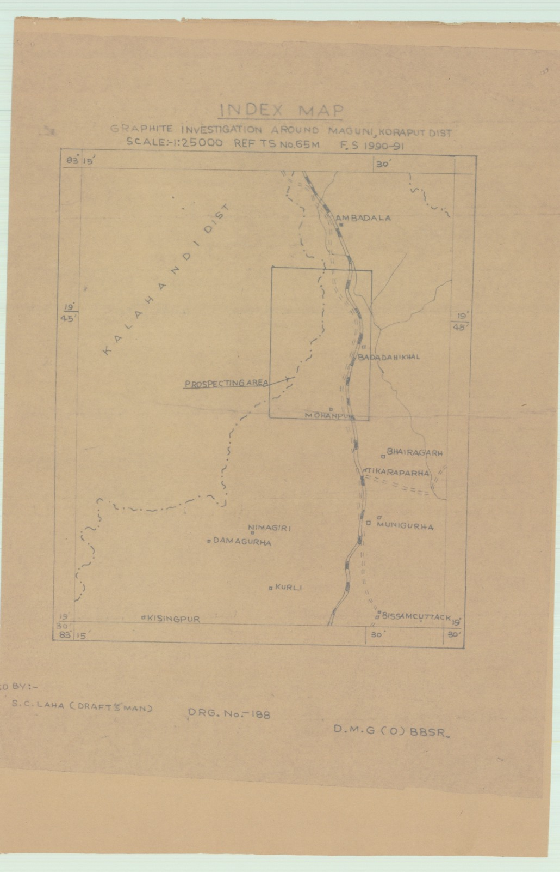

PLATE-II
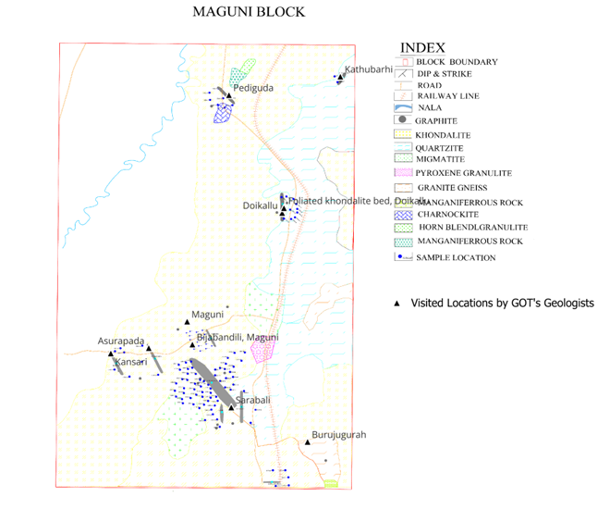

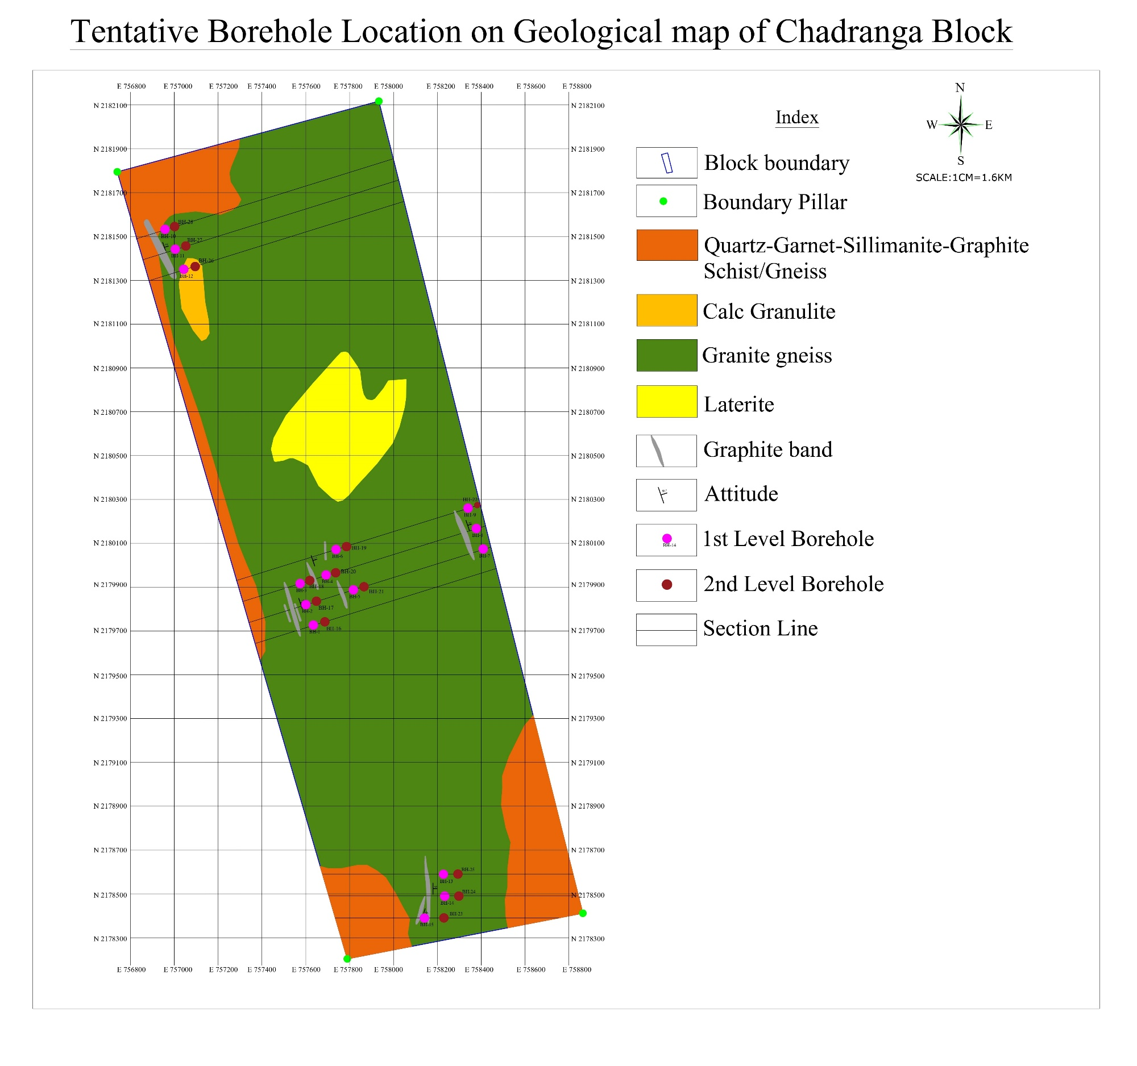
Plate-III

Plate No–III
Plate-IV
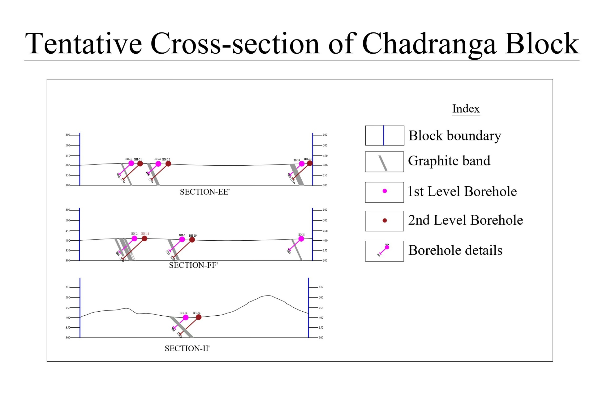

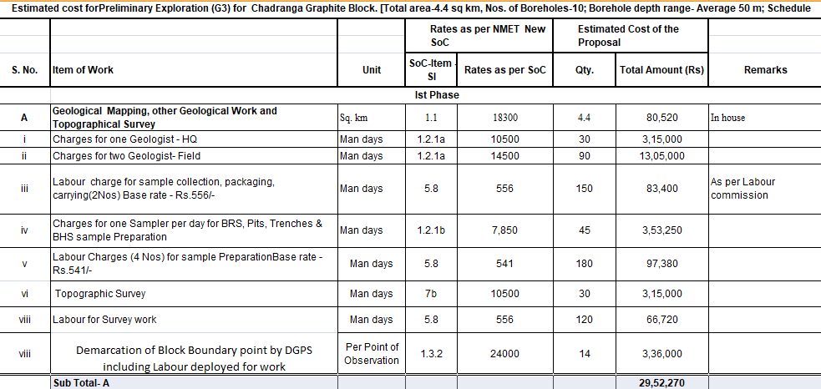

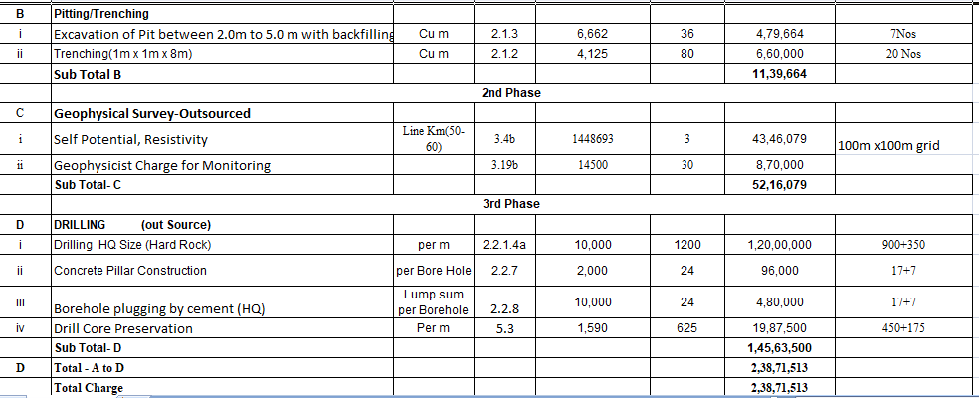

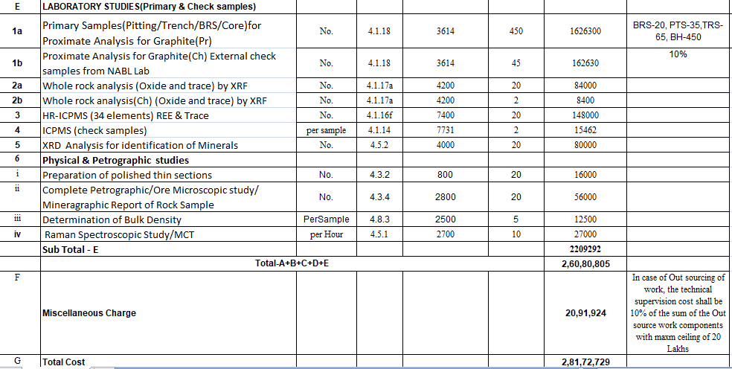

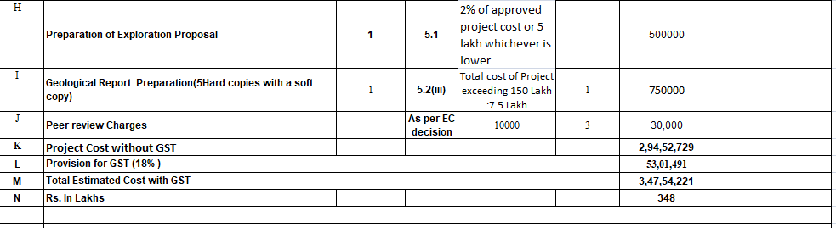

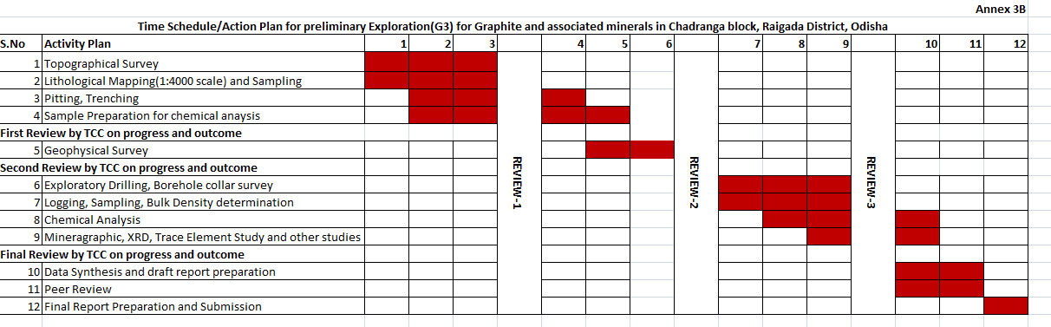

CHECK LIST

Name of Project/Block: PROPOSAL FOR UNDERTAKING PRELIMINARY EXPLORATION
(G3 STAGE) OF GRAPHITE AND ASSOCIATED MINERALS IN CHADRANGA BLOCK, RAYAGADA DISTRICT, ODISHA

Agency: M/s Eartnenviro Lab Pvt. Ltd.
Nodal Personnel (Agency):Shri Prava Ranjan Mishra
Date: 05.05.2026
Sl. No. | Items to be Verified by Agency | Yes/No | Page Number in submitted Document
1 | Geospatial scrutiny completed using KML/coordinate dataset and AOI assessed (including exploration activities, mining areas, eco zones, dependencies). | Yes | 29
2 | Total Forest area in proposed block - with pic from PM Gatishakti portal.  Type of forest (RF/PF/Sanctuary/National Reserve forest) to be mentioned. | Yes / No | 30
3 | Overlap study of previous exploration work carried out in any exploration agencies/departments, or ongoing/proposed exploration work by any agencies/departments done | Yes/No | 30
4 | Baseline data availability (NGCM, NGPM, Geological Maps, Airborne geophysical data etc) on NGDR confirmed and reflected in comments. | Yes / No | 30
5 | Processing of Baseline Geoscience data (NGCM, NGPM, Geological Maps, Airborne geophysical data etc), legacy exploration data of proposed area, integration, analysis and interpretation presented in the project proposal/DPR | Yes / No | 30
6 | Existing leases (ML/CL/EL etc.) in and around project area verified through NGDR/State DGM/Ministry of Mines | Yes / No | 30
7 | Whether the area falling within the buffer zone of International Boundary, Wildlife sanctuary, no-go zone, Biodiversity Park etc. | Yes / No | 31
8 | Literature review and previous findings submitted by agency verified and reflected in DPR/In-principle  (Page number of the particular to be mentioned in Reference / Bibliography) | Yes / No | 13
9 | Whether the agency has carried out field work in the proposed area, collected samples and presented their findings with analytical data in project proposal/DPR | Yes / No | 31-32
10 | Justification for proposed commodities and details of previous work included in DPR/In-principle.  Reference to NMEDT’s ongoing/completed projects verified and included in comments. | Yes / No | 32-33

Other Information
Accreditation of Agency:
Date:24.01.2025 Valid Upto: 23.01.2028
Notification of Agency:
Date:24.02.2025 Valid Upto:23.01.2028
Personnel Deployed
As per QCI NABET -5
Current strength -40
Total no. of Projects funded by NMEDT:
Approved -3
Completed -Nil
Ongoing - 3

Comments of Nodal Personnel (Agency), if any: Nil
Certification
I hereby certify that the above checklist has been duly completed and all verifications have been carried out as per the guidelines.

Signature of Nodal Personnel (Agency):
Name: Shri Prava Ranjan Mishra
Designation: Director
Date: 27.03.2026

- Geospatial scrutiny completed using KML/coordinate dataset and AOI assessed (including exploration activities, mining areas, eco zones, dependencies).

Compliance: Geospatial scrutiny has been completed using KML/coordinate dataset using Google Earth, Previous Legacy Geological Report of GSI, MECL, State DGM using NGDR, NMET portal and AOI assessed (including exploration activities, mining areas, eco zones, dependencies).

Fig-1 BLOCK BOUNDARY ON GOOGLE EARTH

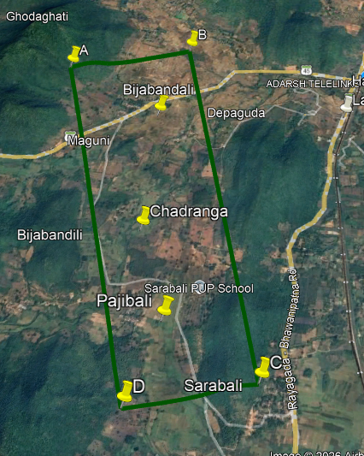

Proposed Block

2. Total Forest area in proposed block - with pic from PM Gatishakti portal.
Type of forest (RF/PF/Sanctuary/National Reserve forest) to be mentioned.

it is found that 1.0 sq. km (Approx.25%) is Forest Land and Rest is non forest with Revenue villages, Roads belonging to Govt. and private land.

Fig-2 BLOCK BOUNDARY ON TOPOSHEET
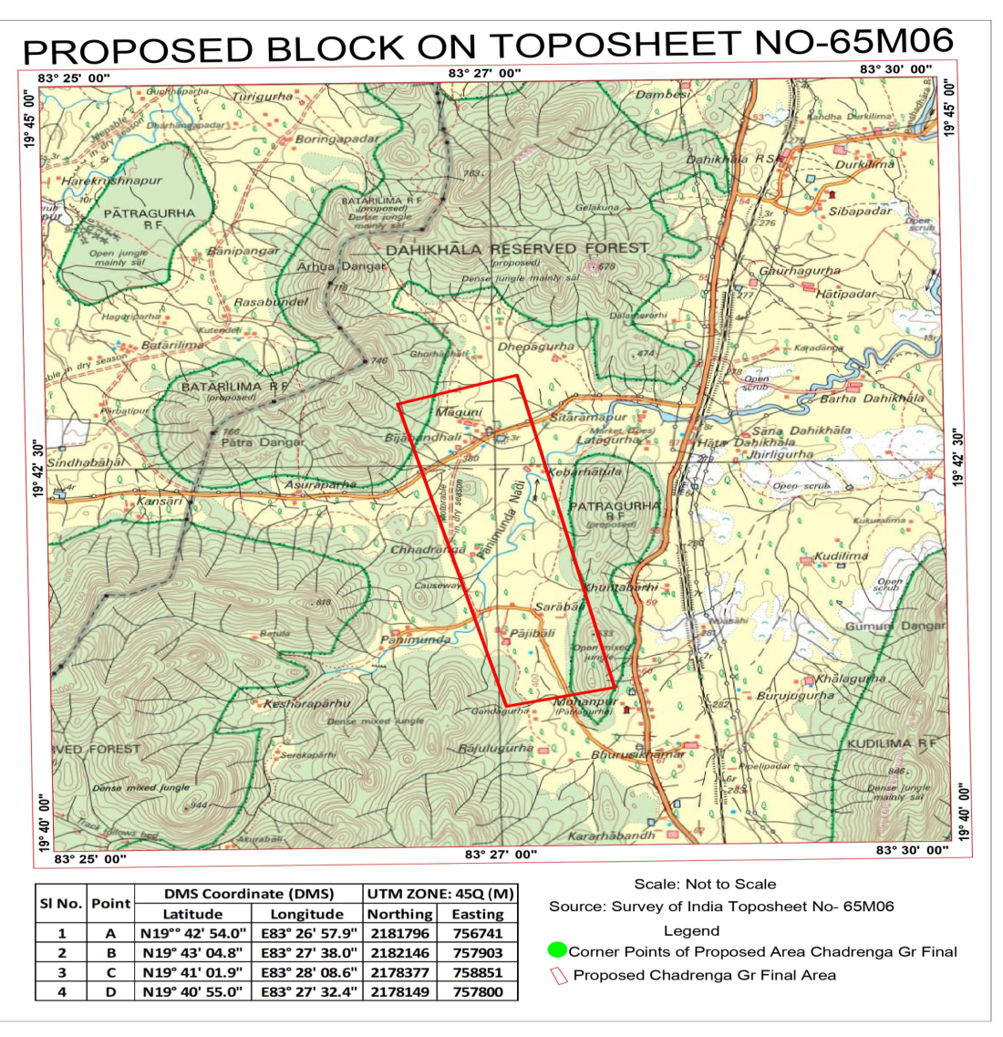

3.Overlap study of previous exploration work carried out in any exploration agencies/departments, or ongoing/proposed exploration work by any agencies/departments done.

Compliance: Overlap study of previous exploration work by exploration agencies/departments like GSI, MECL, State DGM has been carried out in the Block. It is found that no ongoing/proposed exploration work by any agencies/departments has been done (as per available record).

4.Processing of Baseline Geoscience data (NGCM, NGPM, Geological Maps, Airborne geophysical data etc), legacy exploration data of proposed area, integration, analysis and interpretation presented in the project proposal/DPR

Compliance:No NGCM, NGPM, , Airborne geophysical data available for the Block. Legacy Exploration data is

available, Only Geological map is available from which this Block has been framed.

6. Existing leases (ML/CL/EL etc.) in and around project area verified through NGDR/State DGM/Ministry of Mines

No Existing leases (ML/CL/EL etc.) in and around project area found after being verified through NGDR/State DGM/Ministry of Mines

7. Whether the area falling within the buffer zone of International Boundary, Wildlife sanctuary, no-go zone, Biodiversity Park etc.

Compliance:Area is not falling within the buffer zone of International Boundary, Wildlife sanctuary, no-go zone, Biodiversity Park etc.(as per available record)

8. Literature review and previous findings submitted by agency verified and reflected in DPR/In-principle
(Page number of the particular to be mentioned in Reference / Bibliography)

. Compliance: Literature review has been done from Legacy Report of DGM, Odisha during 1990-91

References

D. Sharma&P. Tirkey (1988) | Report on mineral potential survey along Sikarpai-Serigumabelt RayagadaDistrict , Directorate of Geology, Government of Odisha
C.Jena, P.K Panigrahi,&P. Tirkey (1995-96) | Report on mineral potential survey along K.Singapur- singari tract RayagadaDistrict, Directorate of Geology, Government of Odisha
P.K Panigrahi, D. Sharma& B.R Sethi ;(2000-01) | Report on mineral potential survey along budaguda-K. singpur-sikarpai tract RayagadaDistrict , Directorate of Geology, Government of Odisha

9. Whether the agency has carried out field work in the proposed area, collected samples and presented their findings with analytical data in project proposal/DPR

Compliance: Field visit has been done on 5th May to 7th May. Samples have been collected and sent for Analysis. Field photographs are attached here.

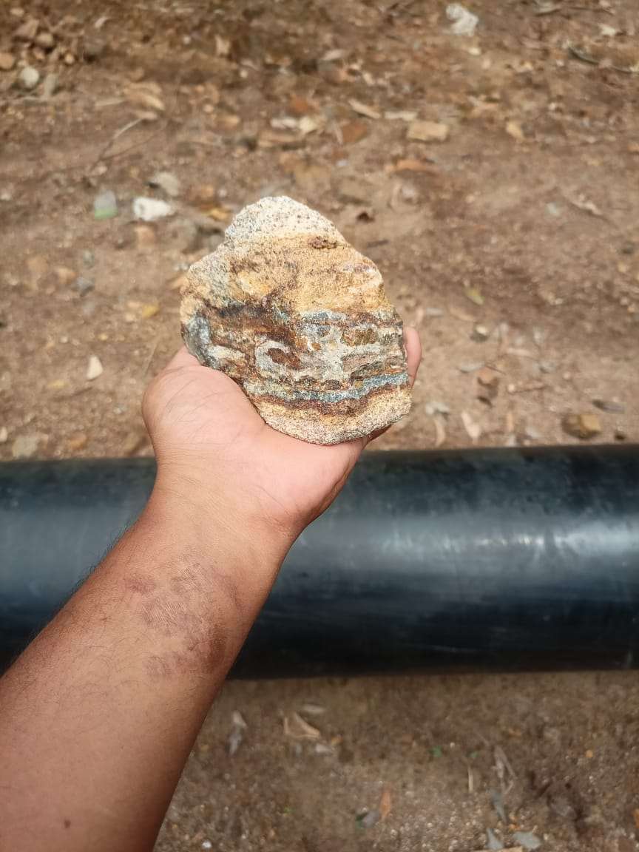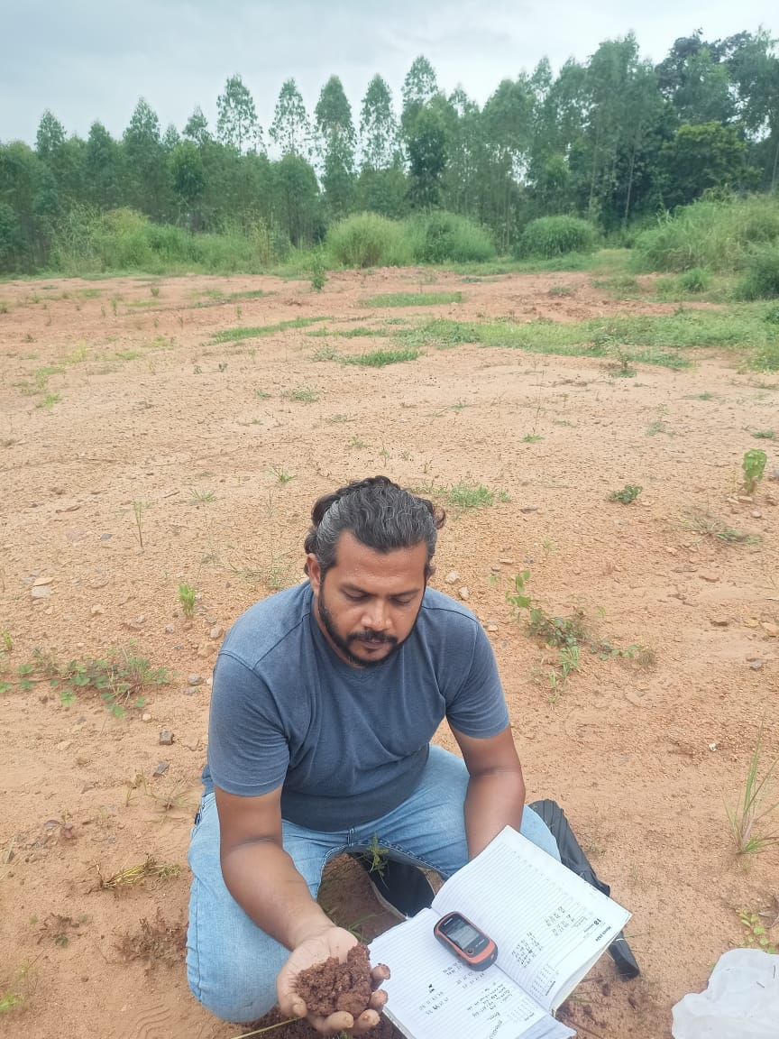

10. Justification for proposed commodities and details of previous work included in DPR/In-principle.

1.Graphite occurrence has been established by DGM, Odisha under G4 matrix of UNFC during 1990-1991.

2.Based on the occurrence of Graphite, Surface exposures, the vein continuity will be established after mapping & G3 level exploration.

3.Preliminary exploration required to know the vertical & lateral continuity of the ore body and its reserve in 333 category as per MEMC rule, 2015.

4.Graphite is a critical mineral for the nation. Hence its exploration will augment the total mineral reserve as well as its use in modern civilization.

Reference to NMEDT’s ongoing/completed projects verified and included in comments.
No NMEDT’s ongoing/completed projects in the area.

