

PRB INFRAPROJCETS PRIVATE LIMITED
(Notified Private Exploration Agency)
WORK PLAN–G3 STAGE EXPLORATION FOR
LIMESTONE IN ANDHARIYANES LIMESTONE BLOCK

MINERAL EXPLORATION PROJECT PROPOSAL
FOR

PRELIMINARY EXPLORATION (G-3 STAGE) FOR LIMESTONE IN ANDHARIYANES BLOCK (6.88 SQ, KMS) UPLETA TALUKA, RAJKOT DISTRICT, GUJARAT”.

UNDER NMET

(TOPOSHEET NO-41 K/1

AREA 3.26 SQ.KM

COMMODITY- LIMESTONE
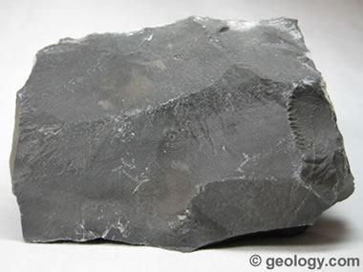
(Industrial Mineral)

(Date of Submission: 11th March 2026)

Submitted by: To,

PRB INFRAPROJECTS PVT.LTD. THE DIRECTOR AND HOD
S-3, S-4 2ndFloor Ratan Heights National Mineral Exploration Development Trust
Medical Square, Untkhana Road Ministry of Mines

NAGPUR- 440024. NEW-DELHI-110001

INDEX

SR. NO | CONTENTS | PAGE NO.
1. | Summary of the Block for G3 stage exploration | 3
2. | Detailed description of the project | 6
3. | Geochemical Analysis of Limestone Samples Collected During Pre-Field Investigation | 8
4. | Scope for proposed exploration | 8
5. | Objective | 9
6. | Previous Work | 9
7. | Block Description | 10
8. | Nature and Quantum of the work | 11
9. | References | 12

LIST OF ANNEXURESAND PLATES

SR.NO. | CONTENTS | PAGE NO.
1. | Time Schedule | 13
2 | Cost Estimation | 14
3 | Plate – 1: Location of Andhariyanes Limestone Block on SOI Toposheet (41K/01) | 17
4 | Plate – 2: Location of Andhariyanes Limestone Block on Google Earth Image | 18
5 | Plate – 3: Geological Map of Andhariyanes Limestone Block | 19
6 | Plate –4: Proposed Borehole Plan For Andhariyanes Limestone (G3) Block | 20

Summary of the Block for G3 stage exploration

Sr.No. | Features | Details
1 | Block ID | Andhariyanes Limestone Block
2 | Current Exploration Agency | PRB Infraprojects Pvt Ltd
3 | Previous Exploration Agency | Geological Survey of India and  Commissioner of Geology and Mining (CGM), Gujarat
4 | Previous Geological Exploration Report | - CGM Gujarat carried out Exploration for Limestone by Predetailed Mineral Survey in Around Various Villages Namely Lalpur, Jam jodhpur and Kalawad Talukas of Jamnagar District.  - CGM Gujarat carried out Detailed Investigation for Chalk And Lime Stone By Drilling Around Dhanak and Mervadar Villages of Upleta Talukas of Rajkot District,  - CGM Gujarat carried out Detailed Investigation for Chalk and Limestone by Drilling Around Andhariyanes and Amrapar Villages of Upleta and Jam jodhpur Talukas of Rajkot and Jamnagar District.
5 | Commodity | Limestone
6 | Mineral Belt | Gaj- Miliolite Formation
7 | Completion Period with entire Time Schedule to complete the project | 08 Months
8 | Objectives | - Geological mapping in 1:4000 scale to delineate the surface outcrops of Limestone.  - Systematic collection of Bed Rock samples and analysis.  - To drill 12 Nos. of boreholes as per MEMC rules 2015 (Being varying thickness of the deposit) to decipher depth persistence and subsurface continuity of bedded deposits.  - To estimate the in-situ resource of Limestone from G3 stage of exploration and preparation of Geological Report (GR).  - Carry out mineral exploration works as per Minerals (Evidence of Mineral Contents) Rule-2015, Mineral (Auction) Rules-2015 and MMDR Amendment act-2015. In turn to facilitate the Government of Gujarat in auctioning of the block.
9 | Whether the work will be carried out by the proposed agency or through outsourcing and details thereof.  Components to be outsourced and Name of the outsource agency | Entire work shall be Carried out by M/s PRB Infraprojects Pvt. Ltd. (In house)
10 | Name/Number of Geoscientists | Two Geologist(2G) & Surveyor (1)
11 | Expected Field days(Geology, Geophysics, Surveyor) | - Geologist:120, Field Days 60 + 60 HQ Days  - Surveyor:30Days
12. | Location
A) | Latitude/ Longitude
  Andhariyanes Block Area
  BP No. | Latitude | Longitude
  A | 21°47'50.39"N | 70° 1'25.56"E
  B | 21°47'57.43"N | 70° 1'33.74"E
  C | 21°47'44.98"N | 70° 1'52.32"E
  D | 21°47'52.02"N | 70° 1'59.48"E
  E | 21°47'36.34"N | 70° 2'21.49"E
  F | 21°47'48.41"N | 70° 3'8.41"E
  G | 21°47'14.92"N | 70° 3'31.39"E
  H | 21°46'49.61"N | 70° 2'39.70"E
  I | 21°47'28.23"N | 70° 1'57.57"E
B) | Nearby Villages | Vadekhan, Andhariyanes Pransla, Dhank
C) | Tehsil /Taluka | JAM-JHODPUR
D) | District | JAMNANGAR
E) | State | Gujarat
13 | Area (hectares/square kilometers)
 | Block Area | 3.26 Sq. Km
 | Forest Area | -
 | Government Land Area | -
 | Private Land Area | -
14 | Accessibility
 | Nearest Rail Head | Porbandar Railway Station
 | Road | NH 27- Nearest highway to the block area
 | Airport | Porbandar Airport– 50km
15 | Hydrography
 | Local Surface Drainage Pattern (Channels) | The drainage pattern is sub-dendritic in general.
 | Rivers/Streams | A seasonal stream flows from the Northwest to the Southwest
16 | Climate
 | Mean Annual Rainfall | 1200mm
 | Temperatures (December)(Minimum) Temperatures (June) (Maximum) | Minimum-20⁰C  Maximum-44⁰C
17 | Topography
 | Toposheet Number | 41K/01
 | Morphology of the Area | The area consists of gently undulating terrain. The area has a moderate gradient towards west. The valleys are found to be Miliolitic limestone bearing.
18 | Availability of base line geosciences  data
 | Geological Map (1:50K) | (Refer Plate No.-III)
 | Geochemical Map | -
 | Geophysical Map (Aerogeophysical,  Ground geophysical, Regional as well as local scale GP maps) | -
19 | Justification for taking up G3 stage mineral exploration | GSI has carried out quaternary geological mapping in the parts of Saurashtra area in the FS 1971-72 and has reported occurrence of high-grade lime stones in the Miliolitic Formation. (Report by K.K. Verma and U.B. Mathur).  The area has been systematically mapped by S. BANDYOPADHYAY (Report on The Geological Mapping of Alech Hills, Saurashtra, Gujarat (Field Season 1973-74 and 1974-75) By S. BANDYOPADHYAY Geologist (Sr.) GSI WR).  In the 1:25K geological map the block area has been shown as Miliolite limestone bearing. (Report on the Study of Volcanics and Associated Rocks of Alech Hills, Jam jodhpur Area, Jamnagar Districts, Gujarat. (Progress Report for the field Season 1991-92) By A Dey, & A.R.V. Chowdary Geologists (Jr)).  The PRB team also visited the area and found that Miliolite Limestone is present in the area. Few samples from the area were collected and analyzed.  4 bed rock samples got analyzed and the average values of Cao, MgO and SiO2 are; 50.5 %, 1.06%, 4.93% respectively.  The block area comprises limestone of the Miliolite Formation which has been reported as good quality limestone. The block has been proposed on the basis of the exploration data present in the CGM reports and on the basis of the geology of adjacent areas.  CGM reported the average CaO % to be 50-53% and average SiO2% to be 24.606 % from collected Chip/grab samples. Hence this block is suggested for the G3 Exploration.  6 Several leases for limestone mining occur in the vicinity of proposed block which is suggestive of high potentiality of the block.

2. DETAILED DESCRIPTION OF THE PROJECT

- Location and Accessibility:
The area lies approximately 5 km northeast of Patan village in Upleta Taluka Rajkot district, Gujrat and is reasonably accessible via rail, road, and air transport. The nearest railhead is Porbandar Railway Station, located approximately 20 km from the area, providing connectivity to regional and intercity routes. National Highway 27 (NH 27) is the nearest major highway, offering efficient road access to the block area and linking it with key towns and cities in Gujarat. The closest airport is Porbandar Airport, situated about 50 km away, which provides domestic flight services, primarily connecting to larger cities like Ahmedabad and Mumbai. This multimodal access makes Andhariyanes suitable for field activities, transportation of equipment, and exploration logistics.
- Physiography:
The proposed block area is in the Upleta Taluka, Rajkot district in the western part of Gujarat. The area is characterized by flat, gently undulating topography with very few mounds and parallel ridges. There are no perennial rivers present in the block. The area is usually dry whole year except during monsoon when few seasonal streams flow which forms sub-dendritic drainage pattern. Moreover, the topography of the whole area is flat with some undulations. The highest elevation is 213m and lowest is152m above msl.
- Regional Geology:
The study region forms part of the coastal belt of Saurashtra in Gujarat, where the geological succession ranges from volcanic rocks of the Deccan Traps to younger sedimentary deposits of Tertiary and Quaternary age. The rock types exposed in the region can broadly be classified into Deccan Trap basalts and younger sedimentary formations deposited along the coastal belt. The Tertiary deposits are represented by two major formations, namely the Gaj Formation and the Dwarka Formation. The Gaj Formation represents an older calcareous facies composed mainly of limestone and marl, whereas the Dwarka Formation represents a younger arenaceous facies consisting of calcareous grits, conglomerates, sandy shale, and sandy limestone.
The Quaternary deposits in the region consist of both consolidated and semi-consolidated sediments. The consolidated limestone deposits are termed the Miliolite Formation, while the overlying semi-consolidated limestone near the coastline is known as the Chaya Formation. These formations occur broadly in three linear belts parallel to the coastline. The Gaj Formation is exposed farthest from the coast, generally near the Deccan Trap hillocks, while the Dwarka Formation occupies an intermediate position. The Miliolite Formation occurs along the coastal belt and overlaps the older formations. The Chaya Formation is restricted mainly to the immediate coastal areas and is characterized by porous, semi-consolidated limestone rich in fossil fragments. Earlier geological studies recognized only the Gaj, Dwarka, and Miliolite formations, whereas later workers further subdivided the Quaternary deposits based on lithological variations.

LITHOLOGY | FORMATION | AGE
Alluvium and residual soils Calcareous Tuffa |  | Recent to Sub-recent
---------------------------------------------------Unconformity--------------------------------------------
Miliolite Limestone | Miliolite | Pleistocene
Chert Vein
Dolerite and Gabbro Intrusions | Deccan Trap | Upper Cretaceous to Eocene
Carbonatite (?) Veins | Deccan Trap | Upper Cretaceous to Eocene
Granophyres | Deccan Trap | Upper Cretaceous to Eocene
Volcanic Breccia | Deccan Trap | Upper Cretaceous to Eocene
Rhyolite Flows/ Trachytic Flows | Deccan Trap | Upper Cretaceous to Eocene
Basalt Flows | Deccan Trap | Upper Cretaceous to Eocene
-------------------------------------------------Base Not Exposed-----------------------------------------

- Geology of the Block
The Andhariyanes block area exhibits a diverse assemblage of volcanic, intrusive, and sedimentary rocks reflecting a complex geological history. The main rock types exposed in the area include trachyte, granophyre, basalt belonging to the Deccan Traps, and limestone of the Miliolite Formation. The region prominently features rhyolite dykes and massive rhyolite bodies, which indicate felsic volcanic activity. These rocks are intruded by gabbro and granophyre dykes, suggesting multiple phases of magma emplacement involving both mafic and felsic magmatic compositions.
Basaltic lava flows dominate parts of the area and are associated with the regional volcanic activity of the Deccan Traps. Intercalated red bole horizons between basaltic units indicate episodic volcanic eruptions separated by periods of weathering and soil formation. The occurrence of volcanic breccia in some locations further suggests episodes of explosive volcanic activity in the region. Minor occurrences of miliolite limestone and basic rocks are also observed, indicating localized sedimentary deposition along with volcanic processes. Overall, the geology of the Pransla area reflects a dynamic geological setting shaped by repeated volcanic eruptions, intrusive magmatism, and subsequent sedimentary deposition during the later geological periods.

- Mineralization potential of Lime stone
Field and analytical data indicate that grade of Miliolite limestone wherever present is suitable for use in chemical industry. The chemical data shows that in almost all the samples CaO content is more than 50%, acid insoluble are slightly over 3%, Fe2O3 less than 2%, MgO less than 1% and LOI about 42%. The data, when compared with the samples collected from the quarries of chemical factories of this area indicate that almost all the Miliolite limestone is of chemical grade. (Manas Roy Chowdhry).
Based on the chemical analysis of four representative bedrock samples from the Andhariyanes area, there is a notable potential for limestone mineralization, particularly for use in industrial applications such as cement and lime production. The samples exhibit high CaO content, ranging from 49.01% to 50.72%, which is a key indicator of good-quality limestone. The MgO levels are relatively low (0.96% to 1.16%), suggesting a predominantly calcitic composition rather than dolomitic limestone, which is favorable for cement-grade material. The SiO₂ content remains moderate (3.75% to 6.09%), with most samples falling below the typical industrial threshold. The thickness and extent of the deposit should be studied in detail to verify the total quantity of the deposit.

3. Geochemical Analysis of Limestone Samples Collected During Pre-Field Investigation
The geochemical analysis of Limestone samples was carried out during the pre-field investigation stage to evaluate their chemical composition is given below –

Sample | Sample | CaO | MgO | SiO2 | Fe2O3 | Al2O3 | LOI
No. | NO. | % | % | % | % | % | %
1 | AD-01 | 50.72 | 1.13 | 3.75 | 1.05 | 0.67 | 41.04
2 | AD-03 | 49.92 | 1.00 | 4.53 | 1.54 | 0.82 | 40.29
3 | AD-05 | 49.01 | 1.16 | 6.09 | 1.91 | 0.97 | 39.33
4 | AD-06 | 50.54 | 0.96 | 5.34 | 1.89 | 0.93 | 38.50

4. Scope for proposed exploration

Sr.No. | Nature of Work | Proposed Work
1 | Detailed Mapping in1:4000scale | 3.26 sq. km
2 | Bed Rock Samples | 30
3 | Specific Gravity Determinations/Bulk Density | 2 no
4 | Sample Analysis (Bed rock samples) | 30
5 | Core Drilling | 150 m
6 | Borehole Depth | 20 m
7 | Drill Core Samples | 100 Nos
8 | Category of Land | Agricultural
9 | Geological Personnel | 02 Nos.
10 | Period of Scheme | 08 months

5. Objectives:
- To delineate the surface outcrop of Limestone both along the strike and dip direction by geological mapping at a 1:4000 scale and collection of bedrock samples and analysis.
- To dig trial pits (15 cu m) to assess the depth persistence of the limestone formation in the first phase.
- In the second phase, based on the outcome of mapping and trial pits, core drilling shall be planned at 800X800m grid as per TCC approval. However, if the thickness of limestone, observed through trial pits, is found to be less than 15-20, more pits shall be dug out at suitable grid pattern.
- To estimate the in-situ resources of different grade of limestone and preparation of Geological Report (GR).
- Carry out mineral exploration works as per Minerals (Evidence of Mineral Contents) Rule-2015, Mineral (Auction) Rules-2015and MMDR Amendment act-2015. In turn to facilitate the Government of Gujarat in auctioning of the block.

6. Previous Work
Fedden (1994) had done pioneering work in Kathiawar peninsula and described the geology of the area in great detail in the memoir “The geology of the Kathiawar Peninsula in Gujarat”. He classified the Tertiary rocks into Gaj bed, Dwarka bed and Miliolites. Mukul et al (1979), Banerjee and Mukhopadhyay (1985) and Garhia et al (1990) from Geological Surveys of India carried osut geological mapping in the area. Gaj, Dwarka and Miliolite have been given Formation status. The Miliolite Formation and the overlying semi-consolidated Chaya Formation have been included within Porbandar Group by Mathuyr et al (1980). Miliolite Formation has been sub-divided into Dhobiya Talav and Adityiana members based on their lithological characters. Recent and Sub-recent coastal unconsolidated deposits have been grouped into Katpur and Mahuva Formation.
A reconnaissance survey of a part of Saurashtra area of Gujarat State was undertaken by KK Verma and UB Mathur (1971-72) in order to examine the Quaternary sediments exposed all along the coast from Okha to Veraval and also in some parts of the interior to distinguish different units of Quaternary on the basis of paleontological and litho logical characteristics of the sediments. Systematic collection of fossils & rocks was made for detailed laboratory studies. The Coast fringing rocks ' included by Fedden under 'Dwarka Beds' have been shifted to sub-Recent formation by them. They also observed that the term 'Miliolite Limestone' is a misnomer as the typical miliolite rock does not contain foraminifers of Miliolidae family in abundance. It is more appropriate to call this group of rocks as 'miliolite rocks' and the stratigraphic unit be referred as 'Miliolite Formation'.
GSI has carried out preliminary appraisal of limestone in coastal areas of Saurashtra, Gujarat for the selection of targets for limestone suitable for SMS, BF. and chemical grade purposes during FS 1997-98 and has reported occurrence of good quality of limestone in Dwarka, Gaj and Miliolite formations. (Dr. Manas Roy Chowdhury).
Geochemical Mapping in Toposheet 41k/01 In Jamnagar, Rajkot and Junagadh Districts, Gujarat (Interim Report- Field Season: 2016-17) FSP CODE: GCM/WR/GUJ/2016/108/2016-17, ITEM NO. 131
Beside this CGM, Gujarat has also carried out several detailed exploration projects in the area and several mining activities are taking place in the vicinity of the proposed block
Beside this CGM, Gujrat has also carried out several detailed exploration projects in the area and several mining activities are taking place in the vicinity of the proposed block.

7. Block description

The proposed Andhariyanes block lies in parts of TS 41K/01 and is bounded by the coordinates as shown in the table below:

Andhariyanes Block Area
BP No. | Latitude | Longitude
A | 21°47'50.39"N | 70° 1'25.56"E
B | 21°47'57.43"N | 70° 1'33.74"E
C | 21°47'44.98"N | 70° 1'52.32"E
D | 21°47'52.02"N | 70° 1'59.48"E
E | 21°47'36.34"N | 70° 2'21.49"E
F | 21°47'48.41"N | 70° 3'8.41"E
G | 21°47'14.92"N | 70° 3'31.39"E
H | 21°46'49.61"N | 70° 2'39.70"E
I | 21°47'28.23"N | 70° 1'57.57"E

Proposed/ Planned Methodology
Detailed Geological Mapping: Topographic survey on1:4000 scale will be carried out in an area of 6.88 sq. km. topographic map with 2m contour interval will be prepared. The geological map will be prepared on 1:4000 scale by adding geological features and structural details etc. picked up during field mapping.

Drilling: Total area of the proposed block is 6.88 Sq. Km. This area is proposed for exploration by drilling 12 nos. of bore holes with cumulative meterage of 150 m with vertical depth of 12m each at 800X800m grid pattern as per as per MEMC 2015 guidelines for G3 stage of exploration in bedded deposits. The borehole locations are given in the Plate – IV.

Core Logging and Sampling: The core recovered from the exploratory drilling shall be kept in the core boxes as per the standard procedure. In the log book core recovery, core recovery percentage, unit length, extrapolated length run-wise shall be recorded. Borehole cores shall be logged run-wise as per litho units, structural features, and rock types. Samples for each borehole shall be collected and prepared for chemical analysis.

Chemical Analysis: The collected samples shall be analyzed by XRF for 6 radicals like CaO, MgO, Al2O3, SiO2, Fe2O3and LOI etc. 10% of the primary samples shall be analyzed as check samples.

ICP-OES/ICP-MS(sequential technique):Sample package for 34 elements i.e.16 other elements Viz. Li, Ga, In, Be, Ge, Mo, Cr, Ta, W, Ba, Co, Rb, Sr, Zr, Nb, Ni;18 REE viz. La, Ce, Pr, Nd, Sm, Eu, Gd, Tb, Dy, Ho, Er, Tm, Yb, Lu, Sc,Y; 02 Actinides viz. U, Th of 12 samples (Per BH 1 Sample).

Geotechnical study: 4 Nos. of Limestone samples will be collected for Bulk Density Determinations and 10 number of thin sections will be prepared and studied.

Geological Report: Prepare a detailed report (Final G3 stage report) along with geological map/cross section etc identifying and establishing the deposit with quality and quantity of the resources with worthy of being raised to G2 scheme of exploration as per MEMC-2015.Data generated fromG-3 level of work and earlier data if any shall be presented in the report as per the guidelines laid down in provisions of Mineral (Evidence of Content) Rules 2015 in the NMET prescribed format for pre review.

8. Nature and Quantum of the work

 | Item of Work | Unit | Proposed quantum
1. | Topographic Survey(1:4000) with 2m contour interval | Sq. Km | 3.27
2. | Geological Mapping (1:4000) | Sq. Km | 3.27
3. | Core Drilling 400x400 grid 6 BH (1 Stratigraphic, 5 BH - 20m each) | M | 150
4. | Sample preparation and Laboratory  Studies | Nos. | 130
5. | Chemical Analysis
A. | Chemical Analysis;(core samples) Primary + Check for 6 radicals i.e. CaO, MgO, Al2O3,  SiO2,Fe2O3andLOI | Nos. | 100
B. | Chemical Analysis; (Surface samples) Primary for 6 radicals i.e. CaO, MgO, Al₂O₃, SiO₂, Fe₂O₃ and LOI | Nos. | 30
C. | External Check sample for analysis of 6 radicals i.e. CaO, MgO, Al₂O₃, SiO₂, Fe₂O₃ and LOI | Nos | 13
D | Composite Samples For 12radicals(CaO, MgO, Al2O3, SiO2, Fe2O3, SO3, P2O5 , LOI, MnO2,K2O,Na2O and Cl.) | Nos | 0
E | ICP-OES/ICP-MS  (sequential technique) sample package for 34 elements i.e.16 other elements viz. Li,Ga,In, Be, Ge, Mo, Cr, Ta, W, Ba, Co, Rb, Sr, Zr, Nb, Ni,:18 REEviz.La,Ce, Pr,Nd, Sm, Eu, Gd, Tb, Dy, Ho, Er, Tm, Yb,Lu,Sc,Y:02  Actinides viz.U, Th(Per BH 3 Sample) | Nos. | 2
6. | Petrographic / mineragraphic study
A | Preparation of thin sections | Nos. | 5
B | Petrographic study report | Nos. | 5
C | Digital Photographs | Nos. | 0
7. | Geotechnical Study
A | Bulk Density Determinations | Nos. | 2
8. | Geological Report Preparation | Nos. | 1

9. Reference

1)GSI report on quaternary geological mapping in the parts of Saurashtra area in the FS1971-72 by K.K.Verma and
U.B.Mathur.
2) preliminary appraisal of limestone in coastal areas of saurashtra, gujarat for the selection of targets for limestone suitable for s.m.s., b.f. and chemical grade purposes by Manas Roy Chowdhury FS 1997-98.
3) Mathur, U.B., Verma, K.K. and Mehra, S., 1980). Tertiary-Quaternary stratigraphy of Porbandar area, Southern Saurashtra, Gujarat. Geol. Surv. Ind. Spl. Pub. No. 11, II, 333-345.
4) NGDR portal.
5) OCBIS portal, GSI.


PRB INFRAPROJCETS PRIVATE LIMITED
(Notified Private Exploration Agency)
WORK PLAN–G3 STAGE EXPLORATION FOR LIMESTONE IN ANDHARIYANES LIMESTONE BLOCK
TIME SCHEDULE
Item of Work | 1 | 2 | 3 | R  E  V  I  E  W | 4 | 5 | 6 | R  E  V  I  E  W | 7 | 8
- Pre field preparation |  |  |  | R  E  V  I  E  W |  |  |  | R  E  V  I  E  W
- Topographic survey and Geological Mapping (1:4000), Bed rock Sampling and Chemical analysis |  |  |  | R  E  V  I  E  W |  |  |  | R  E  V  I  E  W
- Drilling & Chemical analysis |  |  |  | R  E  V  I  E  W |  |  |  | R  E  V  I  E  W
- Interpretation of analytical data, finalization of litho logs, plates |  |  |  | R  E  V  I  E  W |  |  |  | R  E  V  I  E  W
- Review & report preparation / Peer review |  |  |  | R  E  V  I  E  W |  |  |  | R  E  V  I  E  W
6. Final submission |  |  |  | R  E  V  I  E  W |  |  |  | R  E  V  I  E  W

Man power Deployment Geologist party:
2 Geologist-80 Field days+30 HQdays
Sampler Party
1-Sampler–40 Days


PRB INFRAPROJCETS PRIVATE LIMITED
(Notified Private Exploration Agency)
WORK PLAN–G3 STAGE EXPLORATION FOR LIMESTONE
IN ANDHARIYANESH LIME STONE BLOCK

Item | Item of Work | Item | SOR Sr No & Rates |  | Estimated Cost
Sr No. | Item | Unit | Sr.No. | Rates | Qty. | Amount(Rs)
A | Survey work
1 | DGPS Survey BH fixation and RL determination (11 BHP& 6 BP) | Per Point | 1.3.2 | 24,000 | 18 | 432000
2 | Topographic Survey with 2m contour interval & Geological Mapping1:4000 scale
i | A) Charges of 1 Surveyor for Geological mapping & Topogaphic survey | per day | 1.3.1 | 10,500 | 50 | 525000
ii | B) 4 Labours for survey work; | day | 5.8 | 526 | 200 | 105200
 | Sub Total- A |  |  |  |  | 1062200
B | GEOLOGICALWORK (Mapping1:4000scale)
i | Large scale Geological Mapping/Traverse mapping/Detailed mapping in Peninsular India | Per sq. km | 1.1 | 18300 | 6.88 | 125904
ii | Charges for one Geologist-Field | day | 1.2.1a | 14,500 | 150 | 2175000
iii | Charges for one Geologist per-HQ | day | 1.2.1a | 10,500 | 60 | 630000
iv | 2 labours / party | day | 5.8 | 526 | 300 | 157800
v | Sampling-1Samplers | day | 1.5.2 | 7,850 | 45 | 353250
vi | Sampling 4 labours/party | day | 5.8 | 526 | 180 | 94680
 | Piting and Trenching
vii | Pitting (Excavation of pit between 2.0m to 5.0m depth |  | 2.1.3 | 6662 | 15 | 99930
 | Sub Total- B |  |  |  |  | 3636564
C | LABORATORY STUDIES
1 | Chemical Analysis
i | A. ChemicalAnalysis;Primary Core samples for 6 radicals i.e. CaO, MgO, Al2O3, SiO2, Fe2O3 and LOI | Nos | 4.1.17a | 4,200 | 150 | 630000
ii | B. Chemical Analysis;Primary(Surface & Pit) samples for 6 radicals i.e. CaO, MgO, Al+K23:K242O3, SiO2, Fe2O3 and LOI | Nos | 4.1.17a | 4,200 | 40 | 168000
iii | C. External Check sample for analysis of 6 radicals i.e.CaO,MgO,Al2O3,SiO2,Fe2O3 and LOI. | Nos | 4.1.17a | 4,200 | 20 | 84000
iv | Composite SamplesFor12 radicals (CaO, MgO, Al2O3, SiO2, Fe2O3, SO3, P2O5 , LOI, MnO2, K2O, Na2O and Cl.) (Per BH 1 Sample) | Nos | 4.1.1 | 18,100 | 12 | 217200
2 | Physical, Petrological, Mineralogical Studies
i | XRD studies for identification of minerals (Random) | Nos | 4.5.2 | 4000 | 10 | 40000
ii | ICP-OES/ICP-MS(sequential technique)  Sample packagee for 14 REE elements + 9 trace element (U, Ta, Ge, Be, Hf, Sn, As, Rb, Th)  (Per BH 1 Sample) | Nos | 4.1.15 | 7400 | 15 | 111000
iii | Complete Petrographic / ore microscopic study / minerographic report of rock sample (along with 5Nos. Digitial photo micrographs | Nos | 4.3.4 | 2800 | 10 | 28000
3 | Geotechnical Laboratory
i | Bulk Density Determinations | Nos | 4.8.3 | 2500 | 4 | 10000
 | Sub Total- C |  |  |  |  | 1288200
D | DRILLING
i | Core Drilling (BH 12 Nos ) x Each 12 Mtr depth =Total 150 Mtrs | m | 2.2.1.1c | 5,500 | 150 | 825000
ii | Land/Crop Compensation (As Per Requirement ) | Per BH | 5.6 | 30,000 | 12 | 360000
iii | Construction of concrete Pillar (12 BHP + 6 BP) | Per BH | 2.2.7 | 2,000 | 18 | 36000
iv | Borehole plugging by cement | Lumpsum per borehole | 2.2.8 | 10,000 | 12 | 120000
v | Miscellaneous Charges (Transportation of Drilling Rig, Accommodation for Drill Camp, Camp Setting and winding, construction of Approach road (25% of total cost of drilling) | Lumpsum | 2.2.9 | - | - | 206250
vi | Core Preservation. | m | 5.3 | 1,590 | 150 | 238500
 | Sub Total- D |  |  |  |  | 1785750
 | Total A to D |  |  |  |  | 7772714
E | Geological Report Preparation (A minimum of Rs. 2.5 lakhs | 1No. | 5.2 |  |  | 250000
F | Peer review Charges | 1No. |  | 30000 |  | 30000
G | Preparation of Exploration Proposal (2% of the Cost or Rs.5 Lakhs whichever is lower) | 1No. | 5.1 |  |  | 155454.28
H | Total Estimated Cost without GST |  |  |  |  | 8208168.28
I | Provision for GST (18%) |  |  |  |  | 1477470.29
J | Total Estimated Cost with GST |  |  |  |  | 9685638.57
Ninety six lakhs eighty five thousands six hundred and thirty eight only in words

PLATE-I

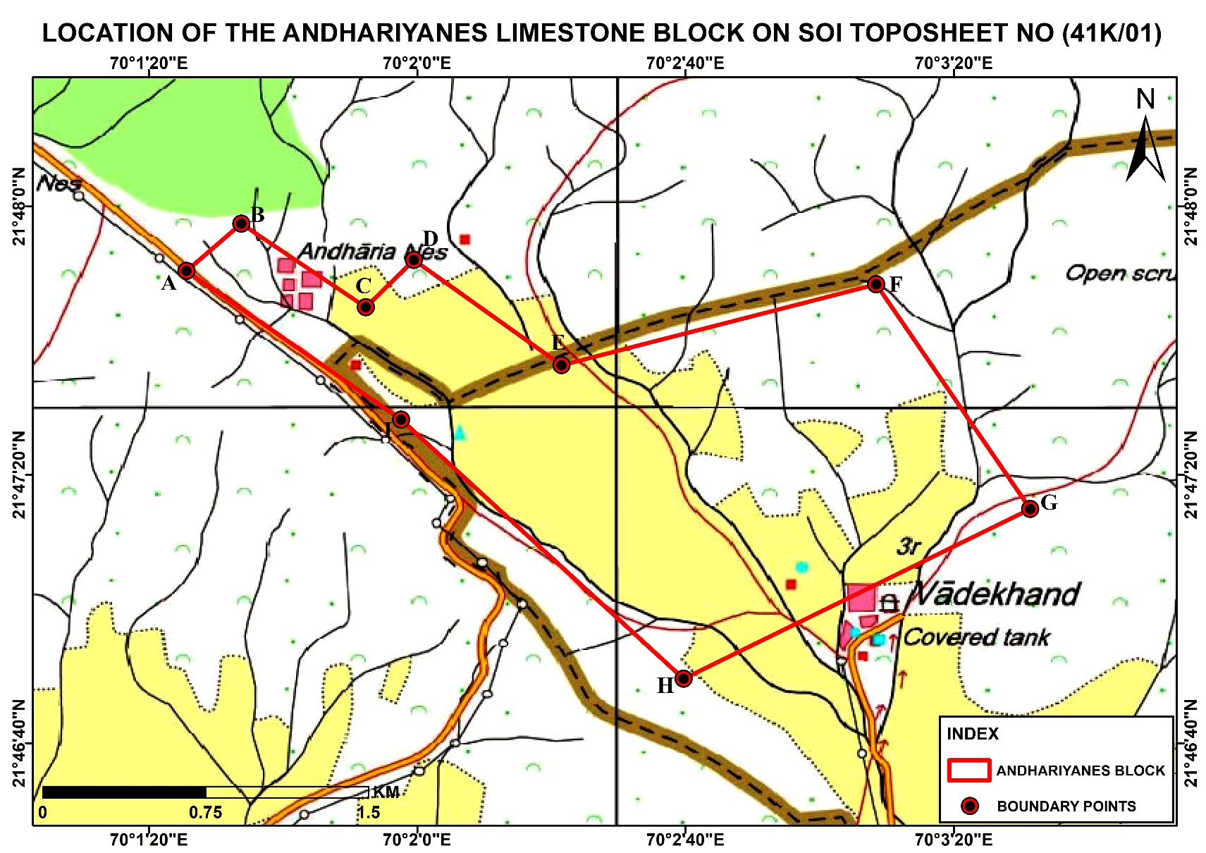

PLATE-II

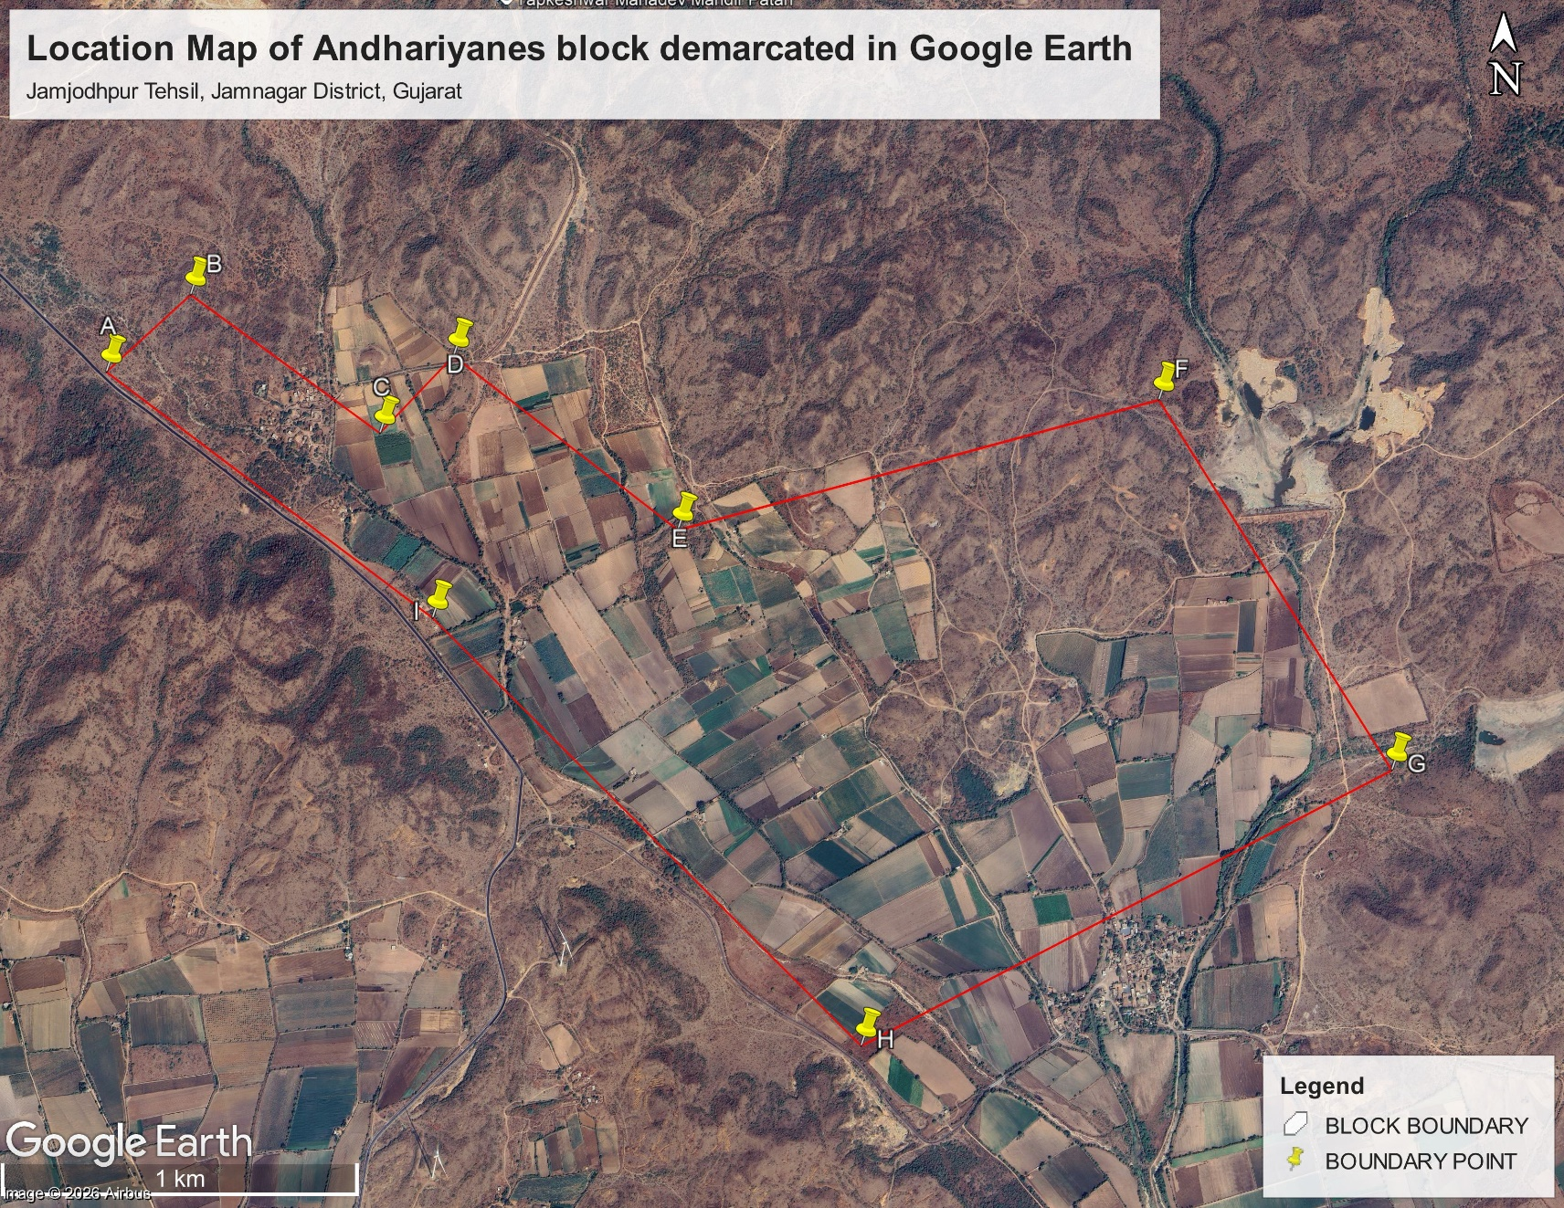

PLATE-III

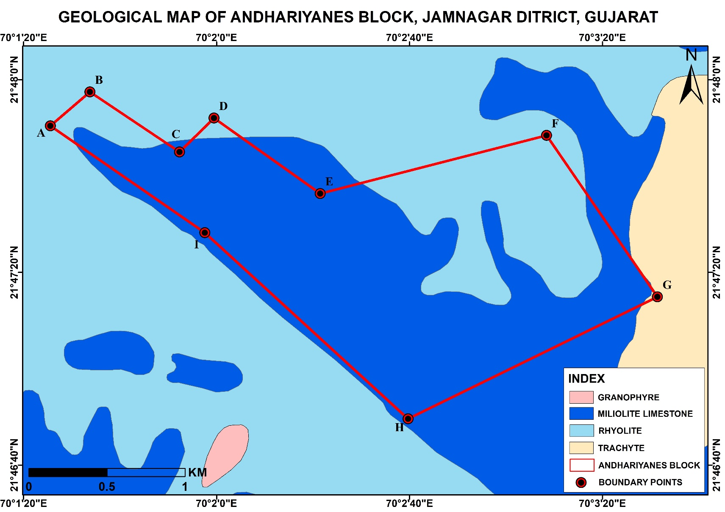
PLATE-IV

PROPOSED BOREHOLE PLAN FOR ANDHARIYANES LIMESTONE (G3) BLOCK AT 400MX400M

