PROPOSAL FOR JARAPA GRAPHITE BLOCK, RAYAGADA DISTRICT,ODISHA STATE FOR G-3 STAGE MINERAL EXPLORATION UNDER NMET

(Commodity: Graphite)

By
EARTENVIRO LAB PRIVATE LTD
BHUBANESWAR

Place:BHUBANESWAR

Date: 25.08.2025
Summary of Jarapa Graphite Block for G- 3 Level Exploration

Sl. No. | Features | Details
 | Block ID | Jarapa Graphite Block
 | Current Exploration Agency | Eartenviro LAb Pvt. Ltd.
 | Previous Exploration Agency
 | Previous stage Geological Report | G-4 level GR of DGM attached in Annexure-I.
 | Commodity | Graphite
 | Mineral Belt | Eastern Ghats Mobile Belt, Rayagada District,  Odisha
 | Completion Period with entire Time schedule to complete the  project | 12months
 | Objectives | GSI has undertaken G4 investigation. They have found strata bound graphite deposit. Qtz-Garnet-Sillimanite-graphite schist/Gneiss is the host rock for Graphite. Total 7 Graphite bodies have been explored in the area . GSI recommended further work for detail exploration.
 | Whether the work will be carried out by the proposed agency or throughout sourcing and details there of. Components to be out  Sourced and name of the out source agency | Survey and Drilling work will be in house. Geophysical survey will be carried out through Outsourcing Agency. The outsourcing agency will be finalized through open tender consequent upon approval of TCC.

 | Name/Number of Geoscientists | 3 Geoscientists
 | Expected Field days (Geology, Geophysics, Surveyor) | Geologist Party days: 150 days  Geophysical Partydays:20days  SurveyParty days: 25days
1. | Location | Jarapa Block
1. | Latitude | 19º16' 30.8''Nto19º17'15.8''N
1. | Longitude | 83º 21'15.4''E to83º20'07.7''E
1. | Villages | Jaraka, Sankesu, Sorupalli, Gunapi
1. | Tehsil /Taluk | Rayagada
1. | District | Rayagada
1. | State | Odisha
2. | Area(hectares/squarekilometres)
2. | Block Area | 350 Ha or 3.5 Sq km
2. | Forest Area | Land scheduled under collection.
2. | Government Land Area | Land scheduled under collection.
2. | Private Land Area | Land scheduled under collection.
3. | Accessibility
 | Nearest Rail Head | Muniguda on East Coast Railway is at20 km from  Jarapa
 | Road | The distance from the district headquarter  Rayagada is about 64km.
 | Airport | Visakhapatnam, the nearest air port is at260 km.
4. | Hydrography
4. | Local Surface Drainage Pattern (Channels) | The drainage system of the area is controlled by Barha Nala flowing from the NW to SE with large meanders and it ephemeral steramlets flowing through the area.
4. | Rivers/Streams | Barha Nala
5. | Climate
5. | Mean Annual Rainfall | 1288 mm
5. | Temperatures(December) (Minimum)  Temperatures(May)(Maximum) | December:7⁰Cto8⁰C  May: 46⁰C
6. | Topography
6. | Toposheet Number | 65M/7
6. | Morphology of the Area | The area in general represents a plain area with minor undulations .The eastern and western parts  Of the terrain are occupied by small hillocks.
7. | Availability of baseline geosciences data
7. | Geological Map (1:50K/25K) | Available Geological Map 1:50000scale
7. | Geochemical Map | Not Available

 | Litho-structuralMap | Not Available
8. | Justification for taking up G3 stage mineral exploration | Graphite occurrence has been established by DGM, under G4 matrix of UNFC during 2001.  Based on the occurrence of Graphite , Surface exposures, the vein continuity will be established after mapping & G3 level exploration.  Preliminary exploration required to know the vertical & lateral continuity of the ore body and its reserve in 333 category as per MEMC rule, 2015.  Graphite is a critical mineral for the nation. Hence its exploration will augment the total mineral reserve as well as its use in modern civilization.

PROPOSAL FOR JARAPA BLOCK, RAYAGADA DISTRICT, ODISHA STATE FOR G-3 STAGE MINERAL EXPLORATION UNDER NMET

Introduction
India is a major global producer of flake graphite. The country has been ranked amongst the top five graphite producers by the USGS (United States Geological Survey). Graphite occurrences are reported from different states including Jammu and Kashmir, Arunachal Pradesh, Gujarat, Jharkhand, Maharashtra,Karnataka,Kerala, Tami lNadu,Andhra Pradesh,Odisha,Chattisgarh and Rajasthan. However, the deposits of economic importance are located in Andhra Pradesh, Chattisgarh and Arunachal Pradesh, which are yet to be exploited. As far as mining and processing of graphite is concerned, Jharkhand, Odisha and Tamil Nadu are the only states where operations are being conducted.
Advent of graphene technology is a boon to the graphite industry. The worldwide as well as in the country, demand for graphite is increasing with the development of non-carbon energy applications such as batteries used in electric vehicles, electric devices and energy storage devices that use graphite. To fulfil demand and to keep a balance between demand and supply, it is essential to develop the resources of graphite in country.
In view of the auction policy of the Government and demand of graphite in the domestic industries, emphasis for assessment of graphite at G-3 level was given by the Directorate of Geology, Odisha. Directorate of Mines & Geology targeted to upscale the exploration status of the earlier reported graphite occurrences.

Physiography &Drainage:
The area under report is a plain terrain with minor undulations. The eastern and western parts of the terrain are occupied by small hillocks and traversed by gullies & nalas. The minimum elevation of the area is about 360 m above msl in the extreme central west and maximum elevation has attained 630m above msl at the southern corner.
The drainage of the area is controlled by the perennial Barha Nala flowing from N to E through the area with large meanders and its ephemeral streamlets. It is more or less sub-dendritic and litho- structurally controlled. The water table in the area varies from 0.67 to 7.28 m. The area is covered by thin vegetation of sal, mango, amla and mixed bushy forests.

Climate:
The area experiences sub-tropical climate with heavy monsoon downpours, extreme cold during winter and pleasant summer. The temperature exceeds in summer up to 46⁰ and falls to 7⁰to 8⁰ during winter. The average annual rainfall in the area is 1288 mm.

Background Geology:
Regional Geology of the area:
The area under exploration forms a part of Eastern Ghats Super Group of rocks of Archaean age comprising litho units like khondalite suite of rocks, charnockite, quartzo-feldspathic gneiss and pegmatite overlain by recent soil and alluvium. The litho units form more or less banded assemblages with permeations of neosomes. The litho units exhibits foliation varying from N30°W-S30°E to N45°E-S45°Wdipping at 45°-75° NE & SE. Pegmatite occurs as intrusives within the migmatised khondalite along the folial plane. Based on the field studies and earlier works of various eminent geoscientists the regional stratigraphy can be enumerated as follows:

Recent to sub recent | Soil/Alluvium
 | Laterite
Intrusive | Pegmatite/vein quartz
 | Porphyroblastic granite gneiss
 | Garnetiferous granite gneiss
 | Charnockite
 | Pyroxene Granulite
Archaean | Khondalite suite: Quartzite, Migmatised Khondalite (± Graphite)

Local Geology and Stratigraphy:
Detail geological mapping over the area revealed that area is mostly soil covered with scanty exposures of the litho units like khondalite and its variants, quartzo-feldspathic gneiss, charnockite and pegmatite which are only exposed along the Barha Nala course forming more or less banded assemblage with variable degree of alteration. Based on their mutual field relation relationships, the following stratigraphic succession is suggested in order of their increasing antiquity.
Recent to sub recent | Soil/Alluvium
Intrusive | Pegmatite
 | Quartzo-feldspathic gneiss (±graphite)
Archaean | Charnockite(migmatised)
 | Khondalite (migmatised/kaolinised/±graphite)

A brief note on the different litho-units of the area is given below

Khondalite:
Khondalite is the oldest rock unit occurring in the area which are migmatised and altered to variable extent. It is exposed in the Nala cuttings & wall sections only and also intercepted in boreholes. It forms a banded assemblage with the quartzo-feldspathic gneiss & often silicified. Because of close proximity to Barha Nala, the lithounits have undergone higher degree of alteration and at places kaolinised. It is reddish brown to buff in colour, medium grained, in equigranular consisting essentially of quartz, plagioclase, sillimanite, garnet and opaque minerals which are scattered throughout the rock mass. Quartz and orthoclase are abundant; plagioclase, sillimanite are common and garnet is noticed as an accessory. Secondary growth is noticed in most of the quartz grains. Under microscope plagioclases are highly saussuritised. Iron solution leached out from the garnet imparts a reddish look to the rock mass. Flakes of graphite occur as dissemination within the khondalite. The trend of foliation in khondalite varies from N30°W-S30°E to N45°E-S45°Wdipping at 45°-75° NE & SE. Intense weathering and alteration of the constituent minerals rendered the litho units moderately fissile at places with kaolinisation of the plagioclage porphyroblasts.

Charnockite:
Charnockites are exposed in bouldery form in the southwestern part of the area on the Nalabanks. Megascopically, it is hard, massive, mesocratic and medium grained rock showing a distinct gneissic trend and exfoliation weathering features. Gneissosity is developed due to dimensional orientation of quartz and feldspar along a definite direction. Granulated prisms of hypersthenes and flakes of biotite constitute the melanocratic bands whereas felsic bands are represented by quartz and feldspar. Mineralogically, it is composed of plagioclase, orthoclase, hypersthenes and quartz as major and biotite are found as accessory mineral. Equi-dimensional quartz and feldspar form a mosaic texture.

The Porphyritic Granite Gneiss is found around the NE part of the block. It is coarse grained and is composed of quartz, feldspar, garnet and mafics. The size of porphyro blasts varies from 3cm to 12cm.the rock is highly jointed and two sets of joints are recorded.

Structure:
Both diastrophic and non-diastrophic structures are found within the litho assemblages. The diastrophic structures include foliation and non-diastrophic structure include joint and impersistent mineral lineation.

Foliation:
It is developed in almost all the lithounits of the area. The regional trends of thefoliation varies from N30°W-S30°E to N45°E-S45°W dipping at an angle of 45°-75° NE & SE.

Joints:
Major strike and dip joints are developed in the area having attitude of N20°E-S30°W to N70°W-S70°E respectively and these are vertical to sub vertical.

Metamorphism:
Petrographical studies of the litho units revealed the following mineral assemblages which signifies the metamorphic episodes the area has witnessed:
- Quartz+Orthoclase+Plagioclase+Sillimanite+Garnet+graphite
- Quartz+Plagioclase+Orthoclase+Hypersthene+Biotite
- Quartz+Orthoclase+Plagioclase+Garnet+Zircon)
The above mineralogical assemblages & their mutual textural characteristics are suggestive of high temperature– high pressure phenomena, characteristic of granulite facies of regional metamorphism. Occurrence of biotite in the fracture planes of garnet and saussuritisation of feldspar are indicative of retrogression.

Mineralisation Details:
Exposures of graphite gneisses are encountered in the Barha Nala section. During geological mapping, it was noticed from the nala wall sections that, both migmatised khondalite & quartzo feldspathic gneiss occur concomitantly & graphite mineralisation is restricted only to the contact zones (more pronounced in the hanging wall side of quartzo - feldspathic gneiss & less often in the foot wall).
Graphite being a constituent mineral of migmatised khondalite occurs as disseminations within the host rock as flakes and fibers. Size of graphite tiny flakes & fibers varies from 1 to 4mm (microphotographs) are randomly distributed exhibiting a preferred orientation in conformity to the foliation.
Petrological study revealed that graphite occurs as disseminated flakes and fibers along the folial plane of migmatised khondalite and quartzo feldspathic gneiss and is of erratic nature. The deleterious minerals present are quartz, plagioclase, orthoclase and opaques. Quartz grains showing secondary overgrowths occur as oval to lensoidal grains with sutured outline. The mineralisation is believed to be remobilized product of carbon during contact regional metamorphism facilitated during emplacement of quartzo-felspathic gneiss.
Mineral potentiality:
Based on the above discussed background exploration inputs & infrastructure facilities of the area,it is imperative that the Jarapa Block area is a potential target for Graphite mineralisation, where benicifiable grade ( F.C average grade 15% )

Scope for proposed exploration:
The scope of the proposed exploration has been formulated on the basis of the findings of G-4 level of exploration done by the Directorate of Geology,Odisha.The scope of proposed exploration is given below:
    - Geological Mapping, Other Geological work & Surveying (1:4000scale) of 3.5Sq km.
    - Pitting :35 nos
    - Trenching(1m x 2m x 15m):(10nos):
    - Drilling(200m x200m):38nos
    - IP,Self Potential, Resistivity and Magnetic (13 Lines km): 3.5 sq. km
    - Sampling: As Necessary
    - Laboratory Studies
    - To update Graphite Resources (334) of 10778.41MTin to G-3 level based on the current findings.

Recommendations of G-3 Level Mineral Exploration Report:
Directorate of Geology did G4 exploration and reported graphite occurrence around Jarapa area in Rayagada district during the F.S 2000-01. Considering the above observations and infrastructure facilities of the area, Graphite Block has been formulated for further exploration by ELPL, Bhubaneswar which has been principally approved by TCC-1, NMET on 29th July 2025 in 79th TCC-I meeting to carve out an auctionable block at G-3 level.
TCC-1 committee recommended conducting a field visit to identify a smaller, more workable area, reducing the block size from 10 sq. km to approximately 3-4 sq. km. It also advised the agency collect representative samples and presents the Detailed Project Report (DPR) in the forthcoming TCC-1 meeting with analysis. Accordingly the present DPR has been prepared. The Analysis Report is as follows:
SAMPLE NUMBER | LOCATION | FIXED CARBON(%) | MOISTURE(%) | ASH(%)
S1 | E 746008,N 2133685 | 17.24 | 7.6 | 31.27
S2 | E 745811, N 2133190 | 14.96 | 6.9 | 43.36
S3 | E 745821, N 2133502 | 6.79 | 3.4 | 56.51
S4 | E 747118, N 2133730 | 21.79 | 9.6 | 29.69

Objectives:
The present exploration programme has been formulated in accordance with the previous work carried out by DG(O) and also as per Mineral (Evidence of Mineral Contents) (MEMC) Rule-2015 & Mineral (Auction) Rule-2015 to fulfill the following objectives:-
Objective of the proposed Exploration is to carry out G-3 level exploration work in the block to make it auction worthy:
- To carry out detailed geological mapping & validate the Geological map on 1:4000 scale and demarcate the rock types of Graphite bearing formations with the structural features.
- To carry out Geophysical Survey
- To drill bore holes in the 200 x 200m section interval as per MEMC Rule2015.
- To drill boreholes to prove depth continuity up to 300 m depth from the ground level.
- To estimate Graphite ore resources (333) in the block as per UNFC norms & Mineral
(Evidence of Mineral Contents) Rules- 2015 & further Amendment Act 2021
Previous Exploration in adjoining area:

- P.K Panigrahi, D. Sharma& B.R Sethi (2000),carried out mineral potential survey along K. Singpur,Budaguda Sikarpai tract in Rayagada district over an area of 375 Sq km spread over toposheets No.65 M/7, Recommendations were made for large scale ,trial excavation mapping to establish extension, grade and depth of the deposit.
- C.Jena, P.K Panigrahi,&P. Tirkey (1995) of Directorate of Geology, Odisha carried out mineral potential survey and first reported the graphite occurrences around K. Singpur & Singari villages of Rayagada District. Geological mapping was carried out in 1:25000 scale in Toposheet no. 65 M/6 & 65M/7 .
- D. Sharma & P. Tirkey (1988) of DG (O) carried out mineral potential survey along Rauli & Singhpur road railway station of Rayagada District over an area of 105 sq km in toposheet no 65M/7 with limited trial excavation and sampling. The area is found to be promising in graphite deposit. Further large scale mapping, trial excavation and systematic sampling is recommended in the area.

Previous Exploration details in the proposed block area:
Geological Mapping for graphite mineralization was taken up by Directorate of Geology during F.S. 2000-01 over an area of 122 sq.km around Jarapa,Tandi & sanakesu village. Out of seven no. of graphite occurrence , 4 Nos were located in the block area.
The graphite occurrence around Jarapa area has F.C content 5.86 to 22.11% .Cut off value of Graphite is 2% F.C.
Block description:
The description of Jarapa Block is given below in the Table No-1.

TableNo-1.1

Jarapa Block
Block corner points/ Cardinal Points | Longitude | Latitude
A | 83°21' 15.4"E | 19°16' 30.8"N
B | 83°20' 06.9"E | 19°16' 24.7"N
C | 83°20' 07.7"E | 19°17' 15.8"N
D | 83°21' 23.3"E | 19°17' 28.3"N

- Planned Methodology:
In order to achieve the objectives, set for Preliminary Exploration (G-3) in Jarapa Block, Rayagada District, Odisha, Surveying, detailed geological mapping, geophysical survey and drilling programme along with sampling and analytical work is proposed in the block. The exploration shall be carried out as per Mineral (Evidence of Mineral Contents) Rule-2015 and Mineral (Auction) Rule-2015.
Accordingly, the details of different activities to be carried out are presented in subsequent paragraphs. It is proposed to drill at least 38 nos BHs phase wise.

Topographic Surveying:

Topographical survey will be carried out in the block area. All the surface features will be picked up and marked on a map on 1:5000 scale. The prospect area would be tied up with the triangulation network. The reduced levels and co-ordinates of boreholes would be determined. The locations of the trenches and pits will be surveyed. The block boundary will be surveyed by DGPS & total station in WGS-84 Datum for demarcation of Block Boundary points.

Geological Mapping:

The detailed geological mappings on 1:4000 scale will be carried out in the block around 3.5Sq km by taking geological traverses in the block. The contacts of different formations, identification of different rock formation, structural features, etc., will be carried out in detail. The geological map on 1:4000 scale will be generated based on the detail geological mapping of the block along with contouring at 5 m interval through Topographic Survey.

Pitting:
At least 35 pits of 1m x 1m x 2m are proposed to expose the ore body beyond nala section along the strike & dip of the ore zone involving 70 Cu.m of excavation before putting BH points.

Geophysical Survey:
Geophysical survey i.e. self-potential survey will be carried out in the entire block along 7 lines of 3.5 sq km at required interval of stations.The geophysical map will be generated based on the SP, IP, Magnetic values recorded in the block. Depth wise interpretation will be provided.

Exploratory Drilling:
Based on the known geology & previous work done geological mapping & Geophysical survey, analytical results of surface, grab samples and delineation of Graphite ore body, drilling at grid interval of 200-200 m is proposed for the known mineralised area. A total of 38 nos. of exploratory boreholes for intercepting graphite lode at 60m, 100m & 140m involving 3640 m of exploratory drilling(Diamond core drilling) have been envisaged for G-3 level of exploration. The boreholes have been planned in such a manner that it is presumed to intersect the Graphite ore at different levels . It is expected that the Graphite ore band will extend both laterally & vertically along dip direction & subsequent BH planning will be done after mapping. The borehole details are given in the table below and shown on the map (Plate-III).
TableNo-2.1

Details of Proposed Boreholes
SL NO. | PROPOSED BHs | LATITUDE | LONGITUDE | PROPOSED DEPTH(m)
1 | BH-1 | N19 16 37.9 | E83 20 17.0 | 114
2 | BH-2 | N19 16 35.1 | E83 20 23.2 | 142
3 | BH-3 | N19 16 31.9 | E83 20 29.8 | 181
4 | BH-4 | N19 16 44.0 | E83 20 19.7 | 22
5 | BH-5 | N19 16 41.2 | E83 20 25.9 | 148
6 | BH-6 | N19 16 38.4 | E83 20 32.0 | 182
7 | BH-7 | N19 16 32.5 | E83 20 44.1 | 274
8 | BH-8 | N19 16 49.8 | E83 20 22.3 | 126
9 | BH-9 | N19 16 47.0 | E83 20 28.5 | 133
10 | BH-10 | N19 16 44.3 | E83 20 34.7 | 196
11 | BH-11 | N19 16 38.8 | E83 20 46.8 | 270
12 | BH-12 | N19 16 33.1 | E83 20 59.2 | 244
13 | BH-13 | N19 16 55.3 | E83 20 26.4 | 26
14 | BH-14 | N19 16 53.3 | E83 20 30.9 | 168
15 | BH-15 | N19 16 50.6 | E83 20 37.4 | 266
16 | BH-16 | N19 16 44.9 | E83 20 49.4 | 224
17 | BH-17 | N19 16 39.2 | E83 21 01.6 | 61
18 | BH-18 | N19 16 36.3 | E83 21 08.0 | 134
19 | BH-19 | N19 17 02.3 | E83 20 26.9 | 111
20 | BH-20 | N19 16 59.5 | E83 20 33.1 | 203
21 | BH-21 | N19 16 56.6 | E83 20 39.7 | 273
22 | BH-22 | N19 16 50.0 | E83 20 53.9 | 152
23 | BH-23 | N19 16 45.3 | E83 21 04.2 | 96
24 | BH-24 | N19 16 42.4 | E83 21 10.5 | 102
25 | BH-25 | N19 17 08.4 | E83 20 29.3 | 114
26 | BH-26 | N19 17 05.6 | E83 20 35.5 | 130
27 | BH-27 | N19 17 02.6 | E83 20 41.8 | 214
28 | BH-28 | N19 16 57.4 | E83 20 53.7 | 131
29 | BH-29 | N19 16 51.4 | E83 21 06.7 | 80
30 | BH-30 | N19 16 48.4 | E83 21 13.1 | 84
31 | BH-31 | N19 17 14.5 | E83 20 31.9 | 88
32 | BH-32 | N19 17 11.6 | E83 20 38.1 | 97
33 | BH-33 | N19 17 08.6 | E83 20 44.5 | 129
34 | BH-34 | N19 17 04.2 | E83 20 54.4 | 114
35 | BH-35 | N19 16 57.0 | E83 21 10.8 | 86
36 | BH-36 | N19 17 21.3 | E83 21 04.7 | 91
37 | BH-37 | N19 17 17.3 | E83 21 15.3 | 78
38 | BH-38 | To be decided |  | 140

Pit & Grab sampling:
During course of mapping, grab samples will be collected from the surface exposures & pit wall/floor sections to examine the grade of ore. The representative samples shall be prepared in field in duplicate. One shall be forwarded to NABL accredited Laboratory for analysis. All primary, internal check and external check channel samples will be analysed for 5 radicals i.e. ( Silica, Ash, FC ,VM and Moisture). Mineralized zones will be delineated at cut-off grade based on the chemical results of primary channel samples. Composite samples would be prepared from the mineralized zones of primary channel samples for each channel. It has been envisaged that 4 Nos. of composite sample would be generated and will be analyzed.

Core Logging:
The borehole cores would be logged systematically. Viz. details of the litho units, colour, structural feature, texture, mineralization, core recovery and Graphite ore type would be recorded.

Core Sampling:
The mineralized part of drill core will be sampled as primary sample. The individual sample will be split into two equal halves and one part will be preserved in the core box for future reference and will be stored in core library, after completion of the project. The whole samples shall be splitted through coning and quartering in field. One part will be analysed as primary samples and second part will be preserved in the camp as duplicate sample, third part will be utilized for preparing composite sample for individual ore band and the fourth part will be kept as either check sample or sample to be used for any other specific purpose. The length of each sample will be kept 1m within the ore zone depending upon the width of particular type of Graphite ore and its physical character. The primary core samples will be analysed for 5 radicals i.e (Silica, Ash, FC ,VM and Moisture).
Around 1200 nos of core samples might be generated from the mineralized zone intersected in the boreholes.All the primary and internal check samples would be analysed for 5 radicals
i.e (SiO2,Ash, FC ,VM and Moisture) by wet chemical analysis method. Composite samples would be prepared from the mineralized zones of primary drill core samples of each borehole as well as from the mineralized zones demarcated.
Total 40 Nos. of composite sample would be generated from drill cores in G-3 level and of exploration and be analyzed for 5 radicals i.e (Al2O3, SiO2, Ash & Moisture, FC and LOI)
Total 1475 nos. of primary samples will be analysed and 147 check samples will be analysed for graphite mineralization i.e. Ash, FC ,VM and Moisture.

147nos of check samples will be sent to NABL External Labs for analysis of graphite mineralization i.e. Ash, FC ,VM and Moisture.
A total of 70 nos representative samples in G-3 level would be analyzed by XRD to ascertain the presence of different mineral phases and 35 nos samples will be analysed for REE including “Wolframite” by ICPMS.

Petrological and Mineragraphic Studies:
Thin and polished section studies on drill cores as well as out-crop samples would be done for ascertaining the petrographic and mineragraphic characteristics. These samples would be drawn from ore zones and host rocks. A provision of 10 specimens (5 specimens from core samples and 5 specimens from outcrop samples) for petrographic and 10 specimens (5 specimens from core samples and 5 specimens from outcrop samples) for mineragraphic studies has been kept in G-3 level.

Bulk Density Determination:
A provision of 14 nos of samples of variable Graphite grade is kept for assessment of bulk density of Graphite ore.

Nature, Quantum andTarget
The quantum of work proposed by ELPL, Bhubaneswar, Odisha in Jarapa Block (G-3 Level of Exploration) is given in Table 5.1. which will be achieved within a time period of 12 months.

Table- 3.1

Proposed Quantum of Work(G-3) Jarapa Block,Rayagada
District,Odisha
Sl. No. | ItemofWork | Unit | QTY
1 | Detailed Geological Mapping(1:4000)&Validation of  Geological Map (1:4000) | Ha | 350
2 | Geophysical Survey (SP/IP/Magnetic)(200x30m) | Line km | 13
3 | Topographic Survey | Ha | 350
4 | Drilling(38 BHs) | m | 3640
5 | Chemical Analysis | Nos | 1475
6 | Check analysis (External) | Nos | 147
7 | X-RD Studies of Mineral Phases | Nos | 70
8 | ICP-MS studies(14REE) | Nos | 35

9 | Composite Sample Analysis | Nos | 40
10 | Preparation of thin section & Polished Section | Nos | 10
12 | Petrographic studies | Nos | 10
13 | Mineragraphic studies | Nos | 10
14 | Bulk density Determination | Nos | 14
15 | Exploration Report | Nos | 1
Man power deployment:
A total of 3 geologists are proposed to be engaged for the exploration works at Jarapa block. Supporting staff like 1 no of surveyor will also be posted for above work. Out source Geophysical team shall be engaged for Geophysical work.

Break-up of expenditure:
The entire drilling activity shall be outsourced and the provisional project cost is estimated at 962.11 lakhs for the entire G-3 Level of Exploration. The details of item wise cost estimate as per the Schedule of Charges as on 01.04.2020 has been prepared and given in Annex -3A and the summary is given below:
Tabel-4.1
Summary of Cost Estimates for Reconnaissance Survey (G-4 Level) Exploration
Sl.No. | Item | Total
1 | Geological Work | 4004700
2 | Pitting & Trenching & Drilling | 45051700
3 | Geophysical Survey | 18833009
4 | Laboratory Studies | 5988976
 | Subtotal(1+2+3+4) | 73878385
5 | Report | 23,59,370
6 | Peer Review | 30,000
7 | Proposal Prepration | 500000
 | Sub total(5+6+7) | 2889370
8 | Outsource Charge | 4767291
 | Total | 81535046
9 | GST(18%) | 14676308
Total cost including 18% GST |  | 96211354
SAY,in Lakhs |  | 962.11 Lakh

References

D. Sharma&P. Tirkey (1988) | Report on mineral potential survey along Sikarpai-Seriguma belt Rayagada District , Directorate of Geology, Government of Odisha
C.Jena, P.K Panigrahi,&P. Tirkey (1995-96) | Report on mineral potential survey along K.Singapur- singari tract Rayagada District , Directorate of Geology, Government of Odisha
P.K Panigrahi, D. Sharma& B.R Sethi ;(2000-01) | Report on mineral potential survey along budaguda-K. singpur-sikarpai tract Rayagada District , Directorate of Geology, Government of Odisha
Mohanty.B.C.&Vajani, P.C.; (1982-83) | Un Published Report on investigation for Graphite around Solagudi and Naringapanga area of Koraput district, Directorate of Geology, Government of Odisha
Sahoo, D.K & B | Un Published Report on investigation for Graphite around Narigapanga area of Rayagada District, Directorate of Geology, Government of Odisha
Sahoo, D.K.; Rout, M.K; Behera, M. R. | GR on Geophysical Investigation for Graphite Around Kanibani-Jugapadar Block, Rayagada District, Odisha, (DGO, 2016-17)
Nanda, S.P. & Rauta, B.S;(2015-16) | Un Published Report on investigation for Graphite around Panchubai area of Rayagada District, Directorate of Geology, Government of Odisha
Patnaik, K.& Mishra,P. C.; (1990-91) | Un Published Report on investigation for Graphite around Maguni in Gunupur Sub-Division of Rayagada District, Directorate of Geology, Government of Odisha
Chakraborty, A. K. & Lal, N. | Report on the geophysical investigation for regional assessment of graphite resources, koraput district, GSI, Odisha

List of Plates

Sl. No. | Description | Ref.PlateNo
1 | Location Map of Jarapa Block of Rayagada District, Odisha  (Scale 1:50,000) | Plate No–I
2 | Geological Map with BH plan of Jarapa Block, Rayagada District, Odisha (Scale 1:2,000) | Plate No–II
3 | Cross-Section of Jarapa Block, RayagadaDistrict, Odisha (Scale 1:2000) | Plate No–III

Plate No–I

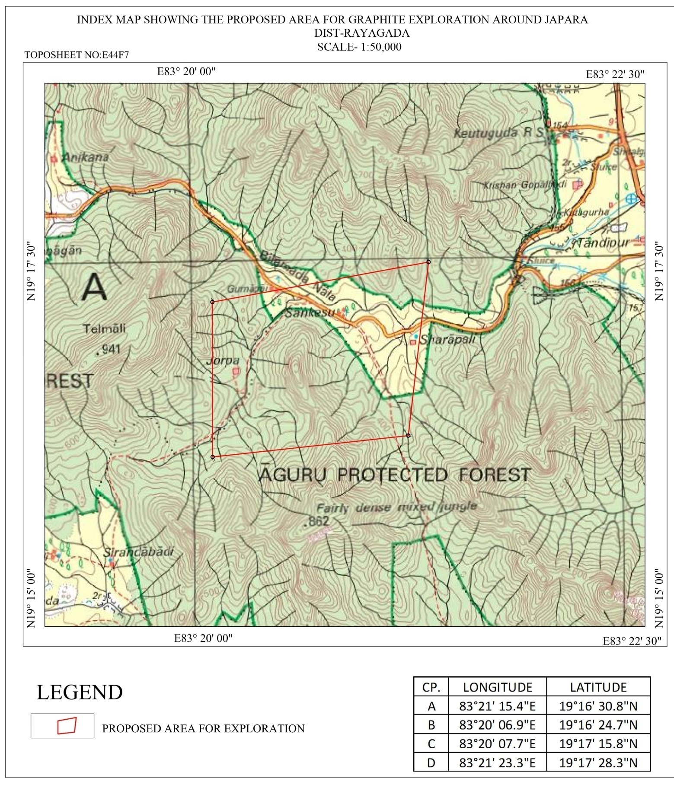

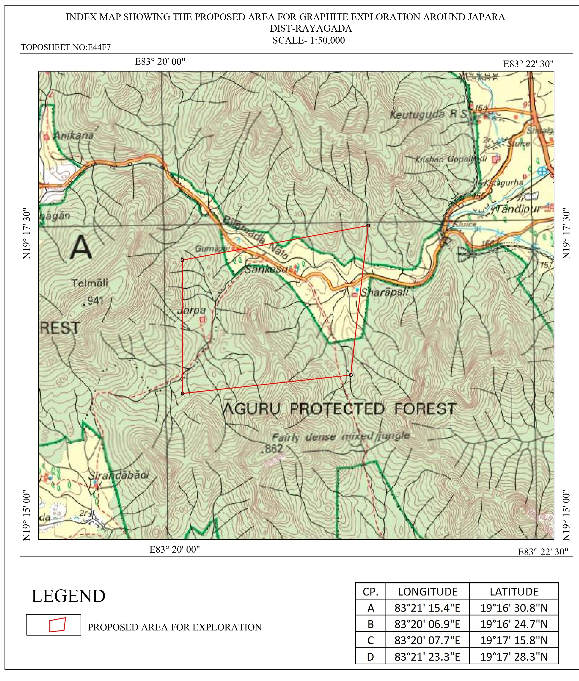

Plate No–II

Geological Map along with Exploration Scheme

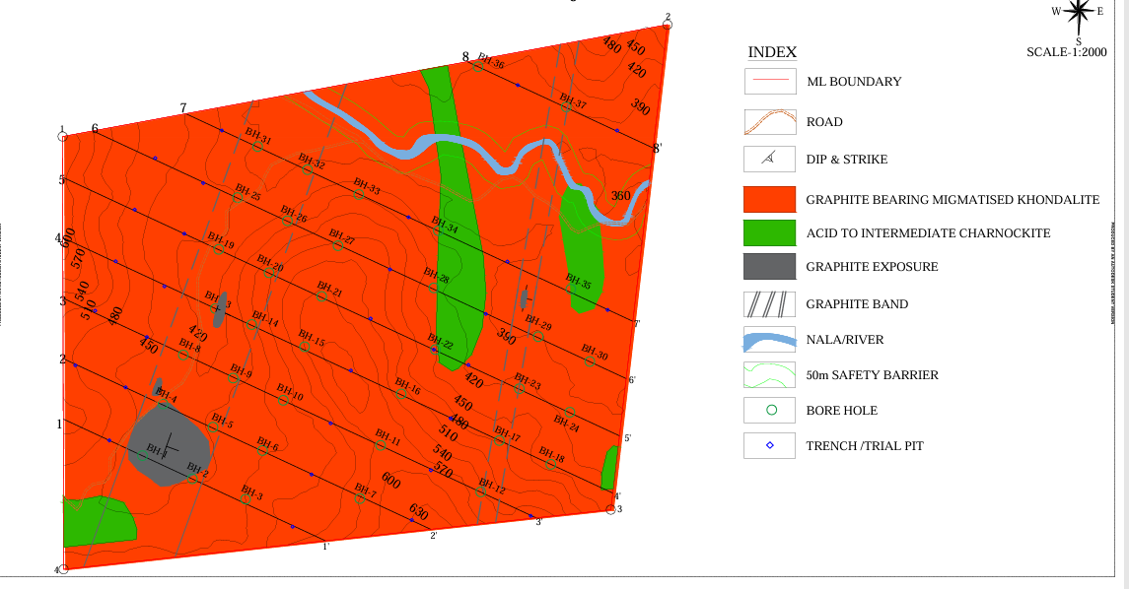

Plate No–III

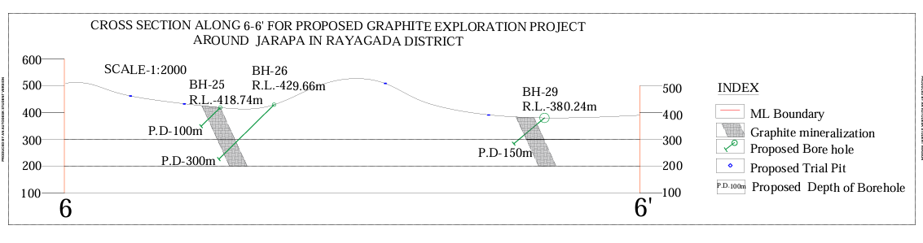

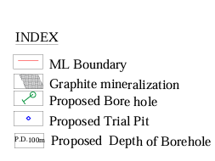

Annex-
Time Schedule/Action Plan for preliminary Exploration(G3) for graphite and associated minerals in Jarapa block, Raigada District, Odisha
S.No | Activity Plan | 1 | 2 | 3 | 4 |  | 5 | 6 | 7 | 8 |  | 9 | 10 | 11 | 12
1 | Topographical Survey |  |  |  |  | REVIEW-1 |  |  |  |  | REVIEW-2
2 | Lithological Mapping(1:4000 scale) and Sampling |  |  |  |  | REVIEW-1 |  |  |  |  | REVIEW-2
3 | Pitting |  |  |  |  | REVIEW-1 |  |  |  |  | REVIEW-2
4 | Sample Preparation for chemical anaysis |  |  |  |  | REVIEW-1 |  |  |  |  | REVIEW-2
First Review by TCC on progress and outcome |  |  |  |  |  | REVIEW-1 |  |  |  |  | REVIEW-2
5 | Geophysical Survey |  |  |  |  | REVIEW-1 |  |  |  |  | REVIEW-2
Second Review by TCC on progress and outcome |  |  |  |  |  | REVIEW-1 |  |  |  |  | REVIEW-2
6 | Exploratory Drilling, Borehole collar survey |  |  |  |  | REVIEW-1 |  |  |  |  | REVIEW-2
7 | Logging, Sampling, Bulk Density determination |  |  |  |  | REVIEW-1 |  |  |  |  | REVIEW-2
8 | Chemical Analysis |  |  |  |  | REVIEW-1 |  |  |  |  | REVIEW-2
9 | Mineragraphic, XRD, Trace Element Study and other studies |  |  |  |  | REVIEW-1 |  |  |  |  | REVIEW-2
Final Review by TCC on progress and outcome |  |  |  |  |  | REVIEW-1 |  |  |  |  | REVIEW-2
10 | Data Synthesis and draft report preparation |  |  |  |  | REVIEW-1 |  |  |  |  | REVIEW-2
11 | Peer Review |  |  |  |  | REVIEW-1 |  |  |  |  | REVIEW-2
12 | Final Report Preparation and Submission |  |  |  |  | REVIEW-1 |  |  |  |  | REVIEW-2

Annex 3A
Estimated cost for Exploration (G3) for Graphite and associated minerals in Jarapa Block, District: Rayagada,Odisha. [Block area- 3.5sq. km; Nos. of Boreholes-38; Borehole depth range- average 60-140m; Schedule timeline- 12 months]
S. No. | Job Description | Unit | Rates as per NMET SoC 2020-21 |  | Estimated Cost of the Proposal |  | Remarks
S. No. | Job Description | Unit | SoC-Item -Sl | Rates as per SoC | Qty. | Total Amount (Rs) | Remarks
A | Geological Mapping, Other Geological work & Surveying (1:4000scale)
i | Geologist: In field | Mandays | 1.2 | 11000 | 150 | 1650000
ii | Geologist: Project Manager at HQ (for overall supervision, liaisoning etc) | Mandays | 1.2 | 9000 | 50 | 450000
iii | Labour charges (for sample collection, packaging, carrying, 2 Nos) | Mandays | 5.7 | 541 | 300 | 162300 | As per Labour Commission
iv | Charges for one sampler per day (for sample preparation) | Mandays | 1.5.2 | 5100 | 60 | 306000
v | Labour charges (4 Nos for sample preparation) | Mandays | 5.7 | 541 | 240 | 129840 | Amount will be reimbursed as per the notified rates by the Central Labour Commissioner or respective State Govt. whichever is higher.
vi | Topographical Survey (for mapping & contouring) | Mandays | 1.6.1a | 8300 | 90 | 747000 | Survey at 2m contour interval, Scale 1:2000
vii | Labour charges (4 labours) | Mandays | 5.7 | 541 | 360 | 194760
viii | Demarcation of lease boundary, Fixation of borehole and determination of co-ordinates & Reduced Level (RL) of the boreholes by DGPS (including charges for labours deployed for the work) | Per point of Observation | 1.6.2 | 19200 | 19 | 364800 | Boundary pillar and BH points Survey & Base Point
 | Sub Total A |  |  |  |  | 4004700
B | Drilling/Pitting/Trenching ( Out sourced)
i | Pitting(27 Nos) | per cu m | 2.1.2 | 3800 | 54 | 205200 | 1.0m*1.0m*2.0m(At 200m interval)
ii | Trenching (1m x 2m x15m): 10 trenches | per cu m | 2.1.1 | 3330 | 300 | 999000 | At 800m interval
v | Drilling(NQ size) - Diamond core drilling, 37 Nos | per m | 2.2.1.4a | 11500 | 3640 | 41860000 | Total drilling meterage of 60m X 14BH = 840m, 100m X 14BH = 1400m and 140m X 10BH = 3,87,51,500 1400m cumulative drilling target of 3,640m.
xi | Drill Core Preservation | per m | 5.3 | 1590 | 1250 | 1987500 | @30m per BH X 37 BHs + 140m (1 complete BH)
 | Sub Total B |  |  |  |  | 45051700
C | Geophysical Survey-Outsourced
i | IP,Self Potential, Resistivity and Magnetic (2 Lines of 3.5 sq. km) | line km | 3.4b | 14,48,693 | 13 | 18833009
 | Sub Total C |  |  |  |  | 18833009
 | Sub Total B+ C |  |  |  |  | 61897209
 | Out Source Charge D |  |  |  |  | 4767291
E | Laboratory Studies
1 | a. Primary Samples for Proximate Analysis of Graphite: Fixed Carbon (FC), Ash (A), Moisture (M) and Volatile Matter (VM) | No. | 4.1.16 | 3000 | 1475 | 4425000 | BRS-90, PTS-35,TRS-150, BH-1200
 | b-External(10%) Check samples from NABL Lab for Proximate Analysis of Graphite: Fixed Carbon (FC), Ash (A), Moisture (M) and Volatile Matter (VM) | No. | 4.1.16 | 3000 | 147 | 441000
2 | Composite Samples | No. | 4.1.1 | 8157 | 40 | 326280
3 | REE analysis of 14 elements by ICPMS | No. | 4.1.13 | 5380 | 35 | 188300
4 | XRD Studies |  | 4.5.1 | 4000 | 70 | 280000
5 | Physical & Petrological Stusies
i | Preparation of thin section | No. | 4.3.1 | 2,353 | 10 | 23530
ii | Complete petrographic study report | No. | 4.3.4 | 4232 | 10 | 42320
iii | Preparation of polished section | No. | 4.3.2 | 1549 | 10 | 15490
iv | Complete mineragraphic study report | No. | 4.3.4 | 4232 | 10 | 42320
v | Digital Photographs | No. | 4.3.7 | 280 | 10 | 2800
vi | Determination of insitu bulk density | Per Sample | 4.8.1 | 3540 | 14 | 49560
viii | Whole Rock Analysis (SiO2, Fe2O3, MnO2, Al2O3, MgO, CaO, BaO, K2O, P2O5, TiO2, V2O5, LOI, S, V) |  | 4.1.15a & b | 5884 | 14 | 82376
ix | Raman Spectroscopy |  |  | 5000 | 14 | 70000
 | Sub Total E |  |  |  |  | 5988976
 | Total A+B+C+D+E |  |  |  |  | 78645676

F | Geological Report Preparation | 1 | 5.2(ii) |  |  | 2359370 | A minimum of 7.5 lakh or 3% of the work whichever is more
G | Peer Review by External Expert | 1 | As per EC decision | 30000 |  | 30000
H | Preparation of Exploration Proposal | 1 | 5.1 |  |  | 500000 | 2% of the approved project cost or 5 lakh whichever is lower
I | Project Cost without GST |  |  |  |  | 81535046
J | GST - 18%
K | Total Project Cost(With GST) |  |  |  |  | 81535046 | 962.11 lakh
 | Total Out Source Job |  |  |  |  | 61897209
 | Out source Charge |  |  |  |  | 4767291
 | Note:
 | 1.Strict Adherance to the Ministry of Finance and GFR Guidelines is mandatory. Every Transaction must adhere to GFR rule 21
 | 2.Incase of delay/non performance, appropriate action will be taken by the competent authority against the agency as per rules/guidelines
 | 3.If any part od the poject is outsourced, the amount will be reimbursed as per paragraph 3 of NMET SOC and item No. 6 of NMET SOC
 | 4.Necessary efforts should be made to minimise any adverse impact on environment during exploration activities
 | 5.Any item of work not mentioned above shall be added as per SOC
 | 6.All geological reports and data are to be uploaded on NGDR by the agency

